



Dissertation Title: Supply Chain Risks Prediction (Delays, Stockouts, and Disruptions) Using Machine Learning

Master title: MSc Data Analytics

Name: ABIN VARGHESE

Year:2024-2026

ABSTRACT

This paper examines how machine learning tools can be used to forecast the major supply chain risks which are delays, stockouts, and disruptions. The contemporary supply chains are in complex and highly interdependent settings in which the conventional mode of forecasting cannot comprehend the non-linear associations, time-lag impacts, and discontinuous impacts. To fill this gap, the study involves a quantitative method and applied the DataCo Smart Supply Chain dataset to formulate and test predictive models. To prepare operational and logistical variables to prepare a modelling, data preprocessing, feature engineering and exploratory analysis were performed. The algorithms of Logistic Regression, Random Forest, and Gradient Boosting were trained and evaluated according to the typical performance indices.
Results suggest that machine learning models are moderately effective in predicting supply chain risks with different models having varying predictive effectiveness. It was established that historical operational data was a major part of the risk prediction performance, and that the interpretability of the model became one of the factors that impacted the trust and adoption of the decision. Statistical analysis showed that it would be possible to make the explanatory power better by involving wider operational and external variables. The paper concludes with the finding that machine learning offers a potential basis to proactive supply chain risk management. Incorporating predictive analytics with organisational processes, businesses can become more resilient, less uncertain, and assist data-driven decision-making in changing and uncertain supply chain contexts.

CONTENTS

ABSTRACT 2

CONTENTS 3

ACKNOWLEDGEMENTS 7

DISSERTATION THESIS 9

INTRODUCTION 10

Brief Description of the Topic 10

Rationale of the Study 10

Problems 10

Research Aims and Objectives 11

Research Questions 11

Brief Methodology Description 12

Synopsis of the Chapters 12

Summary 13

CHAPTER ONE – LITERATURE REVIEW I 14

1.0 Chapter Introduction 14

1.1 Concept of Supply Chain Management 14

1.1.1 Definition and Evolution of Supply Chain Management 14

1.1.2 Importance of Supply Chain Efficiency and Integration 15

1.2 Supply Chain Risk: Definitions and Classifications 15

1.2.1 Definition of Supply Chain Risk 15

1.2.2 Types of Supply Chain Risks 15

1.3 Supply Chain Delays and Their Causes 16

1.3.1 Nature and Sources of Delays in Supply Chains 16

1.3.2 Impact of Delays on Supply Chain Performance 17

1.4 Stockouts and Inventory Risk 17

1.4.1 Definition and Causes of Stockouts 17

1.4.2 Consequences of Stockouts in Supply Chains 18

1.5 Supply Chain Disruptions and Systemic Failure 19

1.5.1 Concept of Supply Chain Disruption 19

1.5.2 Cascading Effects and Network Vulnerability 19

1.6 Complexity and Uncertainty in Modern Supply Chains 20

1.6.1 Globalisation and Supply Chain Complexity 20

1.6.2 Uncertainty, Volatility, and Structural Breaks 20

1.7 Traditional Supply Chain Risk Management Approaches 21

1.7.1 Reactive vs Proactive Risk Management 21

1.7.2 Limitations of Traditional Forecasting and Planning Methods 21

1.8 Identified Research Gaps from Existing Literature 21

1.9 Chapter Summary 22

CHAPTER TWO – LITERATURE REVIEW II 23

2.0 Chapter Introduction 23

2.1 Predictive Analytics in Supply Chain Management 23

2.1.1 Concept of Predictive Analytics 23

2.1.2 Evolution of Predictive Analytics in Supply Chains 23

2.2 Machine Learning Fundamentals for Supply Chain Applications 24

2.2.1 Definition and Types of Machine Learning 24

2.2.2 Advantages of Machine Learning over Traditional Models 24

2.3 Machine Learning Applications in Supply Chain Risk Management 25

2.3.1 ML for Demand Forecasting and Demand Risk 25

2.3.2 ML for Supplier Risk and Lead-Time Variability 25

2.3.3 ML in Logistics, Transportation, and Delivery Risk 26

2.4 Machine Learning Models Used in Supply Chain Risk Prediction 26

2.4.1 Logistic Regression in Risk Classification 26

2.4.2 Tree-Based Models: Random Forest 27

2.4.3 Gradient Boosting Techniques 27

2.5 Evaluation Metrics and Model Performance in Risk Prediction 28

2.5.1 Classification Performance Metrics 28

2.5.2 Model Robustness and Validation Techniques 28

2.6 Explainability and Managerial Use of ML Predictions 28

2.6.1 Model Interpretability and Trust 28

2.6.2 Predictive Insights for Proactive Risk Mitigation 29

2.7 Limitations of Existing ML-Based Supply Chain Studies 29

2.8 Research Gaps Identified from ML Literature 30

2.9 Chapter Summary 30

CHAPTER THREE – METHODOLOGY 31

3.0 Chapter Introduction 31

3.1 Research Philosophy 31

3.2 Research Design 31

3.3 Research Approach 32

3.4 Study Setting and Population 33

3.5 Sampling Technique and Sample Size 33

3.6 Variables and Measurement 34

3.7 Instrument and Data Collection Method 34

3.8 Data Analysis Method 34

3.9 Research Validity and Reliability 35

3.10 Ethical Considerations 35

3.11 Methodological Limitations and Alignment with Primary Research Requirements 36

3.12 Research Timeline 36

3.13 Chapter Summary 37

CHAPTER FOUR – FINDINGS / ANALYSIS / DISCUSSION 38

4.1 FINDINGS 38

4.2 ANALYSIS 62

4.3 DISCUSSION 64

CONCLUDING REMARKS 67

Conclusive Introduction 67

Linking With Objectives 67

Future Scope 68

Recommendation 69

Summary 70

BIBLIOGRAPHY 71

APPENDIX 83

Appendix A: Survey Questionnaire 83

ACKNOWLEDGEMENTS

I would also like to mention that I would like to show my deepest gratitude to my supervisor who persistently guided and provided helpful feedback on this research. I also owe my success to my institution, peers and my family who assist and encouraged me throughout the process of completing this study and they helped me achieve great success in doing so.

Statement of compliance with academic ethics and the avoidance of plagiarism

I honestly declare that this dissertation is entirely my own work and none of its part has been copied from printed or electronic sources, translated from foreign sources and reproduced from essays of other researchers or students. Wherever I have been based on ideas or other people texts I clearly declare it through the good use of references following academic ethics.
(In the case that is proved that part of the essay does not constitute an original work, but a copy of an already published essay or from another source, the student will be expelled permanently from the postgraduate program).

Name and Surname (Capital letters):

.........ABIN VARGHESE...........................................................................................

Date: 05/02/2026

DISSERTATION THESIS

(leave this page empty)

INTRODUCTION

Brief Description of the Topic
The efficiency of the supply chain is a major factor in the competitiveness and sustainability of companies in the fast-changing global business environment. If these types are not managed, they may result in financial losses for the company, operational inefficiency, as well as deterioration in customer service levels. In this regard, machine learning can be considered a valid and useful solution. Modern global supply chains are highly interconnected networks, meaning that disruptions are rarely contained within a single node. The machine learning models are a superior framework because they adapt to the changing trends of disrupted supply chain environments and learn complex non-linear relationships. As a result, risks propagate across multiple tiers through non-linear interactions and delayed transmission mechanisms, increasing the likelihood of cascading failures.

Rationale of the Study
Although there is a lot of literature on risk management in the supply chain, the available research is oriented more towards descriptive analysis or evaluation of the effects of disruptions that have already occurred, thus having fewer proactive tools to predict the risk before it happens. In addition, conventional forecasting and risk assessment frameworks are still inadequate in the non-linear interaction, time-lag effects, and cascading failures in interdependent supply chain networks. Time-lag propagation causes disruptions originating upstream to materialise downstream only after significant delays, which conventional models fail to capture due to their reliance on static lead-time assumptions. Similarly, the bullwhip effect amplifies minor demand fluctuations across supply chain tiers through ordering behaviours, safety stock adjustments, and information asymmetry, resulting in non-linear escalation patterns. Therefore, machine learning represents not merely an alternative analytical tool but a necessary methodological shift for proactive and anticipatory supply chain risk prediction in complex and dynamic environments.

Problems
Although digital supply chain tools are widely used, many organisations still struggle to anticipate and counter threats arising from demand variability, unstable vendors, and external shocks such as pandemics or political instability. A single breakdown among suppliers will lead to delay in transportation, distortion in inventory and subsequent breakdown of customer services. Thus, it is evident that there is a necessity to introduce an integrated, machine-learning-based predictive structure that could help focus on several risks in the supply chain and make proactive decisions in the whole supply chain.

Research Aims and Objectives
Aim:
The aim of this paper is to design and test machine learning predictive models that would predict the key supply chain risks, including delays, stockouts and disruption using real-life operational data to support the making of proactive and data-driven decisions about supply chain management.
Objectives:
- To critically examine the literature on supply chain risk management and machine-learning-based predictive analytics to figure out a theoretical background and their research gaps.
- To preprocess and prepare the DataCo Smart Supply Chain dataset through data cleaning, feature engineering, and exploratory analysis to enable effective predictive modelling of delays, stockouts, and disruptions.
- To train, evaluate, and compare the predictive accuracy of selected machine learning models using appropriate performance metrics.
- To interpret the predictive findings and derive actionable insights that support proactive risk mitigation and enhanced supply chain resilience.

Research Questions
This research will be based on the following research questions:
- What operational and logistical predictors in the DataCo Smart Supply Chain data are valuable predictors of delays, stockouts, and disruptions?
- How well can operational data about past operations be used to predict the probability of supply chain delays, stockouts, and disruptions using trained machine learning models?
- Which machine learning (Logistic Regression, Random Forest, or Gradient Boosting) is the most predictive and reliable when it comes to predicting supply chain risks?
- How well can predictive models build through machine-learning be used to promote proactive risk management and decision-making in the supply chain management?

Brief Methodology Description
The key methodology to use in this dissertation will be quantitative research, and to a certain extent the approach will be supported by machine learning-based predictive analytics. Machine learning methods are especially appropriate because they can be applied to large datasets, non-linear relationships, and can also model more complex interactions between variables of the supply chain that the conventional methods of statistics are not able to serve. This research will utilise the DataCo Smart Supply Chain dataset available on Kaggle, where there is information about customer orders, types of products, logistics, shipping, and the performance of delivery among others. The methodology involves data preparation, supervised model development, and performance evaluation using appropriate metrics.
This study is subject to certain limitations. The dataset may contain missing values or inherent biases that could affect model performance. To mitigate these limitations, data cleaning, imputation techniques, and feature engineering will be applied, alongside careful interpretation of results. Additionally, as the analysis is based on a single dataset, the generalisability of the findings to other industries or geographical contexts may be limited. To mitigate these limitations, cross-validation techniques, robust performance metrics, and careful feature selection will be applied to reduce bias and enhance the reliability of the predictive results.

Synopsis of the Chapters
Chapter One: Literature Review I
This chapter forms a theoretical framework of the study through a critical review of available literature on supply chain risk management, uncertainty, and disruption, and thus provides a context for the research problem and fills major gaps presented by this research.
Chapter Two: Literature Review II
The chapter focuses on machine learning and predictive analytics applications in the management of the supply chain, summarising previous research to justify the choice of data-driven predictive models to be used as proactive risk identification.
Chapter Three: Methodology
In this chapter, it is described that the quantitative research design will be followed, data will be preprocessed and feature engineered, and a machine learning model will be developed, which will become the main research framework to be utilised in predicting supply chain risks.

Chapter Four: Findings, Analysis, and Discussion
This chapter presents the predictive results from the machine learning models developed, compares model performance using evaluation metrics, and integrates these findings with insights from the literature to demonstrate their implications for proactive supply chain risk management and enhanced resilience.

Summary
The research, which brings together data analysis and predictive modelling, will support the development of intelligent, resilient, and proactive supply chain systems. Overall, this study integrates machine learning with real operational data to provide actionable insights that directly support the proactive identification and mitigation of key supply chain risks. The study is firmly grounded in peer-reviewed literature on supply chain risk management, system dynamics, and predictive analytics, ensuring academic rigour and methodological credibility.

CHAPTER ONE – LITERATURE REVIEW I

1.0 Chapter Introduction
Efficiency in the supply chain is vital in organisational performance and resilience. There are many risks that are encountered in modern supply chains in terms of delays, stockouts, and disruptions. These risks may be internal, which may be the suppliers or external, which could be the geopolitical occurrences and natural disasters. This chapter is a review of the literature available regarding supply chain risks and their management. The rationale is to find out the key categories of risks, their causes and the constraints of the traditional risk management methods. The absence of anticipatory and predictive strategies identified in the review preconditions the search for machine learning-related risk prediction in the following chapters.

1.1 Concept of Supply Chain Management

1.1.1 Definition and Evolution of Supply Chain Management
Supply chain management (SCM) is about coordinating the flow of information, finances, and goods between the suppliers and the customers. Initial SCM was focusing on internal efficiency. It was linear and predictable. Companies wanted to save and gain control. The contemporary SCM takes a broader system perspective. Supply chains are perceived as global networks. They encompass a number of supplier levels. They consist, also, of manufacturers, distributors and retailers. Teamwork is now a necessity. Sharing of information helps in making improved decisions. SCM is the control of interrelated operations (Lumineau et al., 2025). The goal is to maximise value. Minimisation of risk and uncertainty is another objective. This is an evolution of the global business trends. The major factors are just-in-time manufacturing. Supply design is also determined by outsourcing (Muldoon et al., 2025). The digital integration links the partners in real-time. The supply chains today cut across various countries. They encounter regulatory and cultural dissimilarity.

1.1.2 Importance of Supply Chain Efficiency and Integration
Efficient supply chains minimise the cost of operations. They also enhance service delivery. Information sharing is made easy through integration. It makes it possible to conduct coordinated decision-making among partners. These partners are the suppliers, warehouses and retailers. Visibility is brought to the fore in literature. Responsiveness and Control are enhanced. It also enhances the resiliency of the supply chain. Combined systems are useful in identifying issues at an early stage (Vizitiu et al., 2025). Delays and stockouts are the common problems. Timely identification minimises the effects of disruption. According to Tang (2006), risk is augmented with poor integration. It subjects the firms to external shocks. Efficiency in supply chains helps in satisfying customers (Ali et al., 2022). It enhances financial performance. It also enhances the agility of organisations. Firms become responsive to changes in the market. SCM is not limited to the operations of the day.

1.2 Supply Chain Risk: Definitions and Classifications

1.2.1 Definition of Supply Chain Risk
Supply chain risk can be defined as events which cause deviation from normal operations. Such incidents are able to influence flow and performance (Chen et al., 2023). Theorists differentiate between risk and uncertainty. Risks are more predictable. They can often be managed. Less predictable are uncertainties. Shocks are extreme occurrences. They create system failures. This can stop production or distribution. Supply chain risks are of various types (Hendriksen, 2023). They may be functional in nature. They can also be strategic. There are external risks associated with the firm. Good risk management requires effective knowledge. Companies should determine the nature of the threat. It is used to design appropriate mitigation plans. There are also known and unknown risks which are separate in the literature. Known risks can be measured.

1.2.2 Types of Supply Chain Risks
Operational risks occur in everyday undertakings. These involve the breakdown of equipment. They also involve machine downtime. Another issue is labour shortages. The gaps in skills may lower productivity. Problems in quality cause waste and rework (Ghelani, 2024). They can delay deliveries. The customer behaviour is a demand risk. The demand can change suddenly. Forecasts may be inaccurate. Uncertainty is enhanced by changes in seasons. Shifts in the market have an influence on sales volumes. Demand pattern may also be distorted through promotional failures (Vandeput, 2023). The suppliers are the sources of supply risks. There is a prevalence of supplier unreliability. Failure to meet deadlines interferes with deadlines. The fluctuation in lead times lowers the accuracy in planning. Output is restricted by capacity constraints. Supplier quality is poor quality to the final products (Raj et al., 2022). Single sourcing exposes the firm to risk. Multi-tiering of supplier formations complicates. The external and environmental risks are beyond the control of the firm. Natural calamities have the potential to halt production. Infrastructures are destroyed by floods, earthquakes, and storms. Pandemics interfere with labour and logistics. Trade routes are influenced by geopolitical instability. Sanctions and tariffs increase prices. Compliance burdens are caused by regulatory changes. Uncertainty is enhanced by political conflict. Tang (2006) singles out global supply chain exposure. Disruption effects are increased by long lead times (Mohammed and Mandal, 2023). Multi-level suppliers lead to a lack of visibility. The risks are transgressed across borders. Small problems may grow out of proportion. It becomes hard to coordinate between regions. Taken together, the literature demonstrates that supply chain risks are multi-dimensional and interconnected, yet are frequently examined in isolation, limiting the ability of existing approaches to anticipate their combined effects.

1.3 Supply Chain Delays and Their Causes

1.3.1 Nature and Sources of Delays in Supply Chains
Delays are caused when a product or information is not moved as expected. Schedules are missed. Lead times increase. This influences the performance of the supply chain in general. One of the major causes of delay is transportation issues. These involve car breakdowns and delays of routes. Another major cause is variation in supplier lead-time. Vendors can fail to be on time. The lack of capacity influences production schedules. The lack of raw materials increases waiting time. Quality issues can be reworked. This adds further delay. The constraints of warehousing are also contributory. Lack of storage space decelerates the inbound and outbound (Rajjoub and Gyuler, 2025). Shortage of labour decreases processing speed. The importance of network structure is mentioned in the literature. According to Lee et al., there was a propagation delay in 1997. Multi-tiered global supply chains exist. A minor problem in the upstream can become widespread. Downstream partners are influenced. There is frequently low visibility at levels. This reduces response speed. Delays are enhanced by unexpected disruptions. Strikes disrupt transportation and manufacturing (Kanike, 2023). Infrastructure losses are caused by natural disasters.

1.3.2 Impact of Delays on Supply Chain Performance
Delays decrease the supply chain service levels. They interfere with the scheduled activities. There is the problem of missed delivery deadlines. Products are not delivered to customers on time (Alzoubi, 2022). This brings about dissatisfaction. Trust in the firm declines. This is usually followed by lost sales and revenue. The problem of stockouts increases. Emergency replenishment increases the cost. Delays are also costly in terms of operation. There is a rescheduling of transport, which incorporates fees. In the long run, labour might be necessary. Accelerated shipping is required. The further the delay is pushed downstream, the larger the impacts become. Upstream problems bring instability on a large scale. It has been demonstrated through literature that frequent delays over a period add up. Companies retaliate by increasing safety stock. An increase in inventory levels augments the holding costs. Storage space demands are increasing. Savings are invested in unnecessary inventories. General productivity becomes compromised. Organisations that are unable to deal with the delays are put at a disadvantage (World Health Organization, 2022). Rapid response to competitors takes market share. Uncertainty is enhanced by operational instability. Overall, these studies indicate that while the causes and impacts of delays are well documented, limited attention has been given to predictive identification of delay risks across interconnected supply chain stages.

1.4 Stockouts and Inventory Risk

1.4.1 Definition and Causes of Stockouts
Stockouts are situations where the inventory is not in a position to satisfy the demand of the customers. Products cannot be made available at the time needed (Monica, 2025). This will interfere with sales and service delivery. One of the significant causes is forecasting errors. There may be an underestimation of demand. The spikes in demand cause pressure on inventory. There is also added uncertainty in demand variability. Stockouts are also caused by the unreliability of suppliers. Delayed shipment slows down the replenishment rate. Issues of quality can restrict inventory. Capacity limit interrupts with production. The problem is aggravated by poor inventory policies. Low safety stock is risky. Wrong reorder points generate gaps. There is increased exposure of global supply chains. Lead times are long. Road networks are complicated. Small disruptions in the upstream are transmitted rapidly. There is a lack of visibility at the levels. Less warning is given to downstream partners. The shortages are then unpredictable. The bullwhip effect increases the demand changes. Minor changes in demand swell in the upward direction. Order batching leads to greater variability. Distortion of information gives the wrong direction. With an increase in variability, inventory planning becomes a challenge.

1.4.2 Consequences of Stockouts in Supply Chains
Stockouts lead to lost sales. The customers are not able to buy the required products. The loss of revenue decreases instantly. Trust among the customers is also destroyed. Constant scarcity decreases loyalty (Sun, 2022). Customers are able to move to rivals. The image of the brand is damaged in the long run. Stockouts bring up the operational costs. The replenishment is often needed as an emergency. Speedy delivery increases logistics costs. The production schedules might require revision. Behavioural response to stockouts is emphasised in the literature (CÂMPIAN and IANCU, 2025). To prevent shortages in the future, Managers can overorder. This response enhances the distortion of demand. Excess inventory may follow. The bullwhip effect increases. The exposure to risks spreads throughout the chain of supply. Constant stockouts lower the quality of services (Mweshi, 2022). The process of order fulfilment becomes unreliable. The lead times become unpredictable. General supply chain performance has deteriorated. The liaison between spouses becomes poor. There is also poor planning accuracy. Literature focuses on the efficient management of stockouts (Immadisetty, 2025). It is necessary to have real-time visibility. The right inventory data makes sound decisions. Inventory policies which are responsive eliminate risk. The amounts of safety stock should be looked at frequently. Risk evaluation: Proactive risk assessment occurs in advance of disruptions. Collectively, the literature suggests that stockouts are often treated as reactive inventory problems rather than as outcomes of interconnected and predictable risk patterns within the wider supply chain system.

1.5 Supply Chain Disruptions and Systemic Failure

1.5.1 Concept of Supply Chain Disruption
Disruptions are the unexpected occurrences that disrupt the normal supply chain operations. They may lead to failure in part. They may cause a complete breakdown of the systems as well. Contrary to delays, disruptions touch on numerous activities simultaneously (Ge, Voß and Xie, 2022). The stoppage of production, transport, and distribution may go hand in hand. The flow of information may also fail. Interruptions do not last equally long. Some are short-term. One of them is temporary supplier failure. Failure of equipment can result in the temporary stoppage of production. With a transport strike, the movement can be halted for days. The other disruptions are long-term. Infrastructure is destroyed by natural disasters. Pandemics decrease the supply of labour (Feist, 2024). It may require months or years to recover. Modern supply chains are vulnerable, as emphasised in the literature. Networks are closely interrelated. The companies depend on common suppliers and logisticians. This enhances dependence among partners. One failure may become viral. It is common to have cascading effects. This highlights the importance of developing predictive mechanisms capable of identifying early warning signals of supply chain disruptions before cascading failures materialise, which directly informs the focus of this research.

1.5.2 Cascading Effects and Network Vulnerability
Upsets are not often confined to a single company. They tend to permeate the supply chain. The transmission of this occurs by the ripple effect. This is in the case of suppliers, manufacturers and distributors. This behaviour is explained by the network theory. Supply chains are interrelated networks. Every node is dependent on others in terms of inputs and outputs. Downstream pressure changes when one of the nodes fails. Secondary failures then take place. These trickle-down effects exacerbate issues of operations. There are delays that are experienced in several stages. There is a disruption of the production schedules. Transport schemes are updated time and again (Hörcher, Singh and Graham, 2022). Studies point to non-linear expansion of the supply chains. Even small upstream effects can have huge downstream effects. Any slight delay on the part of a supplier will stop final assembly. This is aggravated by the lack of inventory buffers. Delays in information interfere with decision-making. Instability is further aggravated by overreactions. The general system performance declines at a high rate. These dynamics reveal the vulnerabilities of conventional risk management. Linear models make independent assumptions of risk (Zhou, Qiu and Zhang, 2023). They have low estimates of interdependencies. They do not realise feedback loops. This causes firms to respond late. The process of recovery is delayed and costly. New strategies are needed for modern supply chains. There is an increasing significance of predictive strategies. Early warning signs can be determined through data analytics. Despite extensive discussion of disruption dynamics, existing studies largely focus on post-event analysis, offering limited support for anticipatory and data-driven risk prediction.

1.6 Complexity and Uncertainty in Modern Supply Chains

1.6.1 Globalisation and Supply Chain Complexity
Global sourcing enhances cost efficiency. The just-in-time practices minimise the inventory. These strategies enhance efficiency in operations. They raise supply chain complexity also. Companies depend on the suppliers who are far away. Lead times become longer. It becomes more difficult to coordinate. There is an additional risk added by multi-tier supplier networks. There are multi-layer dependencies. Lower supplier levels are not very visible. It becomes complex to monitor. A minor problem can be left unnoticed (Ji et al., 2023). It can develop in unforeseen ways. It has been mentioned in the literature that emergent risks are generated by complex systems. These dangers are as a result of exchanges between sovereign nodes. They are not that easily foretold. This is further complicated by international integration. Transit risk is augmented by logistical issues.

1.6.2 Uncertainty, Volatility, and Structural Breaks
The needs of customers evolve quickly. Shocks in the market raise uncertainty. The unexpected twists break the flow of things. Charts' discontinuities enhance unpredictability. Examples include COVID-19. Trade is also influenced by geopolitical conflict. Such occurrences change the demand and supply. Classical statistical models are based on historical information. They assume stable patterns. Such assumptions do not work in volatile environments. Past patterns are no longer an indicator of future (Bromham et al., 2022). The accuracy of the forecast reduces drastically. Decision errors increase. Researchers emphasise the necessity of new solutions. Choi et al. (2016) emphasise dynamic risk assessment. The supply chains need to change constantly. There should be real-time updates of tools. They have to represent shifting circumstances. Non-linear interactions are supposed to be measured. Minor efforts may make big differences.

1.7 Traditional Supply Chain Risk Management Approaches

1.7.1 Reactive vs Proactive Risk Management
Conventional risk management methods are largely reactive. Companies react when something is broken. Measures are taken after the damage has been observed. There are obvious shortcomings in the literature. Expenses become substantially higher. Inefficiency in operations becomes typical (Adepoju et al., 2022). Normal planning is interfered with by emergency responses. There is inefficiency in the use of resources. The purpose of proactive approaches is to predict risks. Companies attempt to be ready in advance. Such approaches have superior prospects. Nonetheless, there are their weaknesses. Many rely on limited data. Information may be outdated.

1.7.2 Limitations of Traditional Forecasting and Planning Methods
Statistical and linear forecasting models are based on the assumption of constant patterns in demand. They also assume autonomy among the supply chain nodes. Such assumptions make the analysis easy. However, they limit accuracy. The modern supply chains are very interconnected. There are hardly any isolated failures. The possibility of a cascading failure cannot be represented by traditional models. They ignore feedback loops. There is non-linear amplification, which is ignored. At first, small disturbances may mushroom. Jumping structural breaks are also missed. Historical trends are interrupted by events such as crises. These weaknesses are pointed out in the literature. According to Tang (2006), these models are not sufficient.

1.8 Identified Research Gaps from Existing Literature
Although a lot of research has been conducted on supply chain risks, the literature does not have integrated, anticipatory prediction models of delays, stockouts and disruptions. Current studies usually concentrate on one type of risk or after-incident review. End-to-end network effects and dynamic, non-linear relationships are rarely studied or addressed in the literature. A significant void exists on data-based predictive models that can forecast various risks at the same time. In particular, there is limited empirical research on predictive models that utilise real-time and multi-source data to simultaneously forecast delays, stockouts, and systemic disruptions in complex supply chain networks.

1.9 Chapter Summary
The concepts of supply chain management, definition of risk and different types of delays, stockouts, and disruptions were reviewed in this chapter. It brought into the limelight the issues of complexity, interconnectivity, and volatility of the global supply chains. Conventional risk management and forecasting practices proved to be ineffective in treating dynamic and systemic risks. The chapter pointed out weaknesses in the anticipatory, integrated and predictive methods, especially on the case of multi-risk evaluation. The results form the basis of the following chapter, which discusses machine learning and predictive analytics as an active way of managing supply chain risks. These limitations justify the exploration of machine learning and predictive analytics in the next chapter as a proactive approach to addressing supply chain risk and uncertainty.

CHAPTER TWO – LITERATURE REVIEW II

2.0 Chapter Introduction
The present chapter is a review of the literature on machine learning (ML) and predictive analytics applied directly to supply chain risk prediction. It centres on the applications of ML models to predict delays, stockouts and supply chain operation disruptions. It is a continuation of Chapter One, but it is more focused on the particular supply chain risk concepts in the actual empirical and methodological research. The section looks at the history of predictive analytics, fundamental ML models, supply chain uses, performance, weaknesses, and gaps. The theoretical background of this review gives a justification of the choice of ML models and the research methodology in subsequent chapters.

2.1 Predictive Analytics in Supply Chain Management

2.1.1 Concept of Predictive Analytics
The concept of predictive analytics is described in the following sections.
Predictive analytics refers to the application of statistical and computational methods to predict future events on the basis of historical and real-time data (Mishra et al., 2022). It forecasts demand variability, late delivery and stock-out in supply chains. The future orientation of predictive analytics is what sets it apart from descriptive and diagnostic analytics. According to Sharma et al. (2022), Descriptive analytics describes the performance in the past, and diagnostic analytics diagnoses the reasons why things have happened. By comparison, predictive analytics forecasts the probable outcomes and allows a business to plan. This will be helpful in risk management in the sense that it will help to identify the risk of failure before it can occur. In the contemporary supply chain, predictive analytics commonly applies machine learning algorithms that may learn intricate trends using vast volumes of information. Predictive analytics is vital in dynamic and uncertain environments because it enables one to deal with non-linear relationships and multiple variables.

2.1.2 Evolution of Predictive Analytics in Supply Chains
Patrick et al. (2022) noted that with the presence of big data and computing power, the use of predictive analytics in supply chain management has increased. Early analytics centred on the use of regression and time series techniques of static forecasting. Such approaches were based on constant tendencies and simplified data. But in the context of globalisation and unstable markets, fixed models were not enough any longer. Scientists started to use machine learning to replicate complex interactions among supply chain variables (Roozkhosh, Pooya and Agarwal, 2022 ). This change was a move towards proactive risk management as opposed to reactive risk management. Predictive analytics combines the information obtained through various sources, such as ERP systems, IoT sensors, and logistics tracking and allows forecasting almost in real-time. It is claimed by the scholars that predictive models would give a better understanding of the possible disruptions and variability of the demand. Recent research indicates that predictive analytics has helped enhance operational efficiency and minimise the effects of stockouts and delays through enhancing decision-making.

2.2 Machine Learning Fundamentals for Supply Chain Applications

2.2.1 Definition and Types of Machine Learning
According to Kühl et al. (2022), Machine learning is a perceived branch of artificial intelligence that allows computer systems to learn patterns based on data without having to be programmed to do so. There are major types of ML algorithms, namely, supervised, unsupervised, and reinforcement learning. Supervised learning is based on using labelled historical information to train models to forecast future results. This type is primarily used in risk prediction, including the categories of deliveries which will be late, or the categories of stockout. Classification and regression models are part of supervised learning. Classification is used to predict categorical variables, such as risk/no-risk, whereas regression is used to predict continuous variables, such as delivery lead time. Unsupervised learning finds the patterns that are not defined beforehand, and it is commonly utilised in clustering or anomaly detection. Reinforcement learning is a learning process where agents receive feedback in terms of rewards to learn the best decisions. Kang and Bhawna (2025) have argued over Supervised learning is commonly used in the context of supply chains since the results of past problems are often known. As an example, classifiers are trained on order histories of labelled late and on-time deliveries. Regression models predict numerical results such as lead times.

2.2.2 Advantages of Machine Learning over Traditional Models
According to Grebovic et al. (2023) Machine learning models have a number of benefits over the conventional statistical approach. To begin with, non-linear associations between variables of the supply chain can be captured with the help of ML. Ding et al. (2025) noted that Traditional models tend to be linear and independent, and thus, they are not able to capture the reality of the world. The ML algorithms, including random forests and gradient boosting, are capable of dealing with high-dimensional data, including the interaction between features. Second, ML promotes learning in the adaptive sense, that is, the model can be advanced as additional data is available. This is required in flexible supply chains where trends evolve very fast. Third, ML can combine various types of data, such as structured logistics data, time series demand, and unstructured external information. Even though there are advantages to ML models, there are also challenges. The black boxes are some of the models that are difficult to interpret for the decision-makers. Interpretability and predictive performance are usually at odds. The empirical work proves that the ML models,s such as random forest and gradient boosting, are better at the supply chain forecasting tasks than classical time-series and regression models.

2.3 Machine Learning Applications in Supply Chain Risk Management

2.3.1 ML for Demand Forecasting and Demand Risk
According to Bhavikatta (2025), the key to the prevention of stockouts and overstocking is accurate demand forecasting. The problem of machine learning models has found extensive use in enhancing demand forecasts. Hasan (2024) noted that Random forest, gradient boosting, and deep learning are the techniques that can capture intricate seasonal and trend patterns of sales data. ML is able to make use of many predictors at once, such as promotions, holidays and economic signals, when compared to traditional exponential smoothing and ARIMA models. Research indicates that ML models are very useful in minimising errors in forecasting and enhancing the accuracy of inventory planning, reducing the risk of stockouts and reducing the cost of holding inventory. More sophisticated deep learning methods, such as convolutional and recurrent networks, have been constructed to find deep time-related features of multi-channel data. Even explainable ML methods are becoming available to provide an interpretation of predictions. Demand forecasting forms part and parcel of the supply chain risk prediction since misaligned forecasts are one of the major contributors to inventory and service level shortages.

2.3.2 ML for Supplier Risk and Lead-Time Variability
The sources of operational risk that are important are supplier reliability and lead time variability. Machine learning can be trained to recognise the pattern of supplier lateness and determine the chances of supplier lateness in future (Steinberg et al., 2023). Random forest and gradient boosting are examples of supervised models that have been shown to have high predictive performance in identifying high-risk suppliers and making predictions about delivery lead times. These models rely on historical performance of suppliers, order sizes and logistics data in order to predict probabilities of delays. Reinforcement learning has also been suggested to find causal evidence that can be used to generate actionable information on causal factors that create delays or delays during delivery. Predictive models allow companies to make proactive changes to their sourcing strategies so that they do not do business with suppliers with a high predicted risk, or they diversify their sourcing strategy to be resilient. Anticipating delays by suppliers aids in the optimisation of inventory buffer and production schedules (Kouvelis, Chen and Xia, 2023). By eliminating unexpected lead-time variability, companies will be able to mitigate disruptions and have a smoother operation.

2.3.3 ML in Logistics, Transportation, and Delivery Risk
The major areas where delays and disruptions are realised include logistics and transportation (Touloumidis et al., 2025). The prediction of transportation delays has been carried out using machine learning, based on route information, weather data, road traffic, and carrier performance. There is an opportunity to predict probable late deliveries with classification models and pre-emptively change the route or resource reallocation. The anomaly detection by means of ML recognises some abnormal patterns that could signify possible upcoming interruptions, e.g., sudden traffic jams or carrier delays. Real-time awareness of risks is enhanced with predictive analytics models using time series and anomaly detection techniques (Jain and Mitra, 2025). Patterns of delays are identified with models that are trained on historical delivery data and environmental data based on the context of the given environment. Another way in which ML can assist in optimising the logistics network is through the detection of bottlenecks in transportation flows and the provision of corrective measures. Anticipatory information on the performance of the delivery process enables companies to modify their logistics plans well in advance, including shipment consolidation or using alternative transport companies. This improves the agility and responsiveness of supply chains. Strong risk forecasting in logistics helps in an enhanced level of customer service and lower operational expenses.

2.4 Machine Learning Models Used in Supply Chain Risk Prediction

2.4.1 Logistic Regression in Risk Classification
Supervised ML models. Logistic regression is a model that is employed to classify binary problems (Zaidi and Al Luhayb, 2023). Logistic regression is used in predicting outcomes in supply chain risk, i.e. on-time vs late deliveries or risk vs no risk. This model is appreciated for its simplicity and readability, having coefficients that demonstrate the effect of predictors. Logistic regression works well in situations where the relations between predictors and outcomes are approximately linear. Logistic regression in empirical research to predict delay in delivery potentially works sufficiently well, but can be improved by more complex models where data have non-linear characteristics. However, it can still be a helpful benchmark model, and it will be important in cases where a decision rule that is interpretable is necessary. The fact that logistic regression enables the supply chain manager to assign probability scores would enable him or her to establish risk levels and prioritise an action based on its likelihood of occurrence.

2.4.2 Tree-Based Models: Random Forest
Random forest is an ensemble learning model that is made up of several decision trees (Salman, Kalakech and Steiti, 2024). It is a commonly applied technique in supply chain risk forecasting because of its good performance and capability of dealing with non-linear associations. Random forest models consist of several decision trees constructed with random data and feature groups, followed by a combination of the findings to create strong predictions (Jalal et al., 2022). This method minimises overfitting and enhances generalisation. Random forest has been demonstrated to be a better predictor of delays in supply chain applications and an excellent stockout risk classifier when compared to traditional regression models. Its capability to rank feature importance assists in determining the major risk drivers, i.e., variability of the lead time or demand spikes.

2.4.3 Gradient Boosting Techniques
Gradient boosting is an efficient ensemble algorithm which progressively constructs weak learners, with a new model eliminating the mistakes of the former. Among the algorithms used in this method are XGBoost and LightGBM, which are commonly utilised in predictive analytics. Gradient boosting models perform well when there are complicated relationships and patterns between predictors. Rezki and Mansouri (2024) have argued over Gradient boosting has continued to achieve high predictability of delays and disruptions in the prediction of supply chain risks. These models are capable of incorporating numerous predictors such as time series, supplier performance measures, and logistics predictors. Gradient boosting has an iterative optimisation capability that enables it to act on non-homogeneous data. Gradient boosting has some strong features, but has to be tuned to hyperparameters to prevent overfitting and guarantee generalisation.

2.5 Evaluation Metrics and Model Performance in Risk Prediction

2.5.1 Classification Performance Metrics
In predictive modelling, evaluation metrics play a very important role. In classification tasks, such measures as accuracy, precision, recall, and F1-score are commonly used. Accuracy is a measure of total correctness, but may be misleading inthe case of class imbalance (Farhadpour, Warner and Maxwell, 2024). Precision refers to the fraction of results of predicting positive that were actually positive, whereas recall refers to the fraction of results that were positive and were correctly predicted. F1-score offers an accurate balance between precision and recall, and is a powerful risk prediction measure in cases where false negatives (risks falsely missed) may be expensive. In the supply chain risk models, it can be significant to prioritise recall to guarantee a high level of risk event detection. Regression tasks make use of measures of prediction errors in continuous outputs that are regression-based, like Mean Absolute Error (MAE), Mean Squared Error (MSE) and Root Mean Squared Error (RMSE). Reduced error measures denote an improved forecasting power. Choosing the right metrics is important to make sure that the evaluation of models is similar to the business goals and the riskiness.

2.5.2 Model Robustness and Validation Techniques
Evaluation of model robustness is done through validation techniques like cross-validation, which evaluates model performance on any other set of data. K-fold cross-validation minimises the chances of overfitting as it guarantees generalisability (Gorriz et al., 2024). The results of external validation on different datasets enhance the trust in model predictions. Temporal validation, in which models are trained on delayed periods of time, is significant in dynamic supply chain settings (Abushaega et al., 2025). Strong models can be used to show similar performance over multiple data splits and time. Monitoring of the model performance should be continued, since the situation in the supply chain changes. The pattern may change, and model drift can be experienced, which necessitates retraining of models to preserve predictive accuracy.

2.6 Explainability and Managerial Use of ML Predictions

2.6.1 Model Interpretability and Trust
There is a range of interpretability of machine learning models. Direct models, such as logistic regression, have comprehensible coefficients. More complicated algorithms,s such as random forest and gradient boosting,g are more accurate but less transparent. The use of explainable AI (XAI) methods (SHAP values, feature importance scores) assists in understanding the impact that inputs have on predictions. The reason why explainability is desirable in the management of supply chain risks is that managers have to believe in the model outputs to make decisions. Clear models allow the stakeholders to know the drivers of risk, which promotes implementation and responsibility (Battaglia et al., 2025). The interpretable models also allow communicating with the organisational decision-makers in case they do not know the technical side. By making systems interpretable, one can guarantee confidence in predictive systems and risk mitigation strategies.

2.6.2 Predictive Insights for Proactive Risk Mitigation
Predictive insights enable organisations to shift to proactive risk management as opposed to reactive (Adeniran et al., 2024). The early indicators of probable delays or stockouts allow being proactive, meaning to modify inventories, reschedule shipments, or contract other suppliers. ML models are capable of sending alerts in case of risk overrun, which is suitable for acting quickly. Active risk reduction leads to enhanced operational continuity and customer satisfaction (Kiani and Mousavi, 2024). Predictive insights aid the strategic decisions, such as planning capacity, allocation of resources and diversifying sourcing. ML prediction can be incorporated into the decision support system to increase the responsiveness and resilience in volatile environments. Companies that use predictive insights have an advantage over the market since they can foresee disruption and mitigate its effects.

2.7 Limitations of Existing ML-Based Supply Chain Studies
Even though there is advancement in the applications of ML, there are limitations (Tufail et al., 2023). Most of the studies are based on the use of a single type of risk as opposed to the prediction of delays, stockouts, and disruptions simultaneously. The vast majority of current studies are limited and concentrate on demand forecasting or on predicting the delay of delivery without combining various risk aspects. The quality of data, such as the absence of values and discrepancies in records prevent the accuracy of the models. The data of the supply chain is usually across different systems and forms, making integration harder (Lin, Lin and Wang, 2022). There are many possibilities that models trained on a single dataset fail to generalise to other datasets because of different working environments. Certain complicated ML-based models are not interpretable, which lowers confidence in the decision-makers. Besides, the majority of studies make use of offline historical data, not real-time streams, making them less responsive. The performance requires continuous updating and adaptation of the model to the changing conditions. It also no real-life case studies that can be used to test model deployment in operative real world scenarios. These constraints indicate the necessity of multi-risk predictive models that are holistic and real-time.

2.8 Research Gaps Identified from ML Literature
There are a number of gaps in the literature that are filled by this study. To begin with, there are no predictive models that are integrated to determine the delays, stockouts and disruptions. The large majority of the research provides findings on specific risk types without considering the combined ones (Leichsenring et al., 2022). Second, most models are only based on past data and not on real-time predictive models, which can adapt to dynamic situations. Third, the multiple ML models are not comparatively evaluated in real conditions of functioning. The number of studies that give a complete performance comparison between logistic regression, random forest and gradient boosting models in the environment of supply chain risk is limited. Fourth, the literature does not provide any studies that involve the use of explainability to assist in managerial decision-making and predictive accuracy. These shortcomings are the impulse behind the present research to come up with multi-risk forecasting models made up of integrated, interpretable, and robust ML models that can be applied to supply chains.

2.9 Chapter Summary
In this chapter, the literature review covered machine learning and predictive analytics used in supply chain risk management. It discussed the history of predictive analytics, the most important models of ML, demand forecasting, supplier risk, and logistics. The part talked about measures of evaluation, interpretability of the models and managerial value of predictive information. The limitations of the existing studies were also revealed, and unified multi-risk prediction and real-time adaptability were determined. The research gaps were also mentioned to justify the methodological decisions in the following chapters. The chapter provides a strong theoretical framework for the ML-based prediction of risk and preconditions the empirical research procedures that are going to be described in Chapter Three.

CHAPTER THREE – METHODOLOGY

3.0 Chapter Introduction
This chapter reports on the methodology of the study, which is the positivist philosophy and descriptive research design. It describes the method of deduction, sampling and the method of data collection. The use of SPSS analytical techniques is outlined, ethical considerations, limitations in the study and research timeline are outlined leaving transparency, reliability and adherence to research objectives.

3.1 Research Philosophy
The research is based on a positivist research philosophy. Positivism deals with objective reality. It presumes that knowledge is quantifiable (Maretha, 2023). Facts are not dependent on the researcher. The study is based on quantitative information. It does not allow subjective interpretation. Events which can be observed are the supply chain risks. Disruptions, stockouts and delays are quantifiable. Machine learning requirements demand formal data. Positivism embraces the use of data to make decisions. Statistical analysis corresponds to positivist thinking. The philosophy is in favour of hypothesis testing. Hypotheses on relationships between variables are objective. Standardised techniques will reduce bias. Quantitative surveys produce measurable responses. Statistical software is capable of analysing results. The results may be generalised with constraints. This school is applicable in predictive research. It helps in regression and correlation analysis. It enhances the scientific rigour of the study. Finally, positivism focuses on the replicability and reliability of the discoveries in the new settings (William, 2024). The accuracy and validity of the model are improved by using large datasets. The error measures and validation methods can be used to assess predictive performance. The method facilitates the comparison of the alternative machine learning models. It also advocates evidence-based suggestions to enhance the resilience of the supply chain and efficiency.

3.2 Research Design
The research design is descriptive in nature. Descriptive research describes prevailing conditions (Yang et al., 2022). It does not play around with variables. The design is concerned with the existing supply chain practices. It considers the ability to predict the occurrence of risks. Stockouts, delays and disruptions are explained. The design will assist in discovering trends. It facilitates inter-respondent comparison. There are trends in risk perception that can be analysed. Survey-based research is appropriate for descriptive design. It enables the gathering of normalised data. It is easy to quantify responses. The architecture embraces machine learning preparedness checking. It takes into account operational and risk-related variables. It is in line with the objectives of predictive modelling. This is a design that guarantees clarity and organisation. It facilitates proper statistical analysis. It enhances the validity of results. In addition, this design allows summarising a large amount of data in forms of tables and graphs. It allows frequency, mean and variance analysis. Cross-sectional information is effective in capturing data within a restricted period of time (Chirico, 2023). The methodology helps to develop baseline information for future analytic or causal research. It also boosts the openness in reporting outputs. Unchanging measurement scales enhance comparability and facilitate solid preprocessing of data to be used in machine learning.

3.3 Research Approach
The research is deductive in nature. Theory is the beginning of deduction. It takes a path toward the testing of data. The current theories on supply chain risk are discussed. The concepts of machine learning prediction are used. Theories are derived from literature. Assumptions are tested by collecting data (Rodriguez‐Dominguez et al., 2022). Relationships are proven by statistical techniques. Results either support or disapprove expectations. The methodology provides logical consistency. It connects theory and empirical evidence. It does not have exploratory ambiguity. Quantitative research is appropriate for deduction. It helps in regression and correlation analysis. It empowers the investigation led by a hypothesis. This is a method that is consistent with positivism. It increases objectivity and accuracy. It aids in the generalisation of findings. Also, the deductive approach permits operationalisation of variables clearly in terms of the theoretical construct. It provides that there are measurable indicators that have to be set before data gathering. Empirical evidence is systematically used to test the model assumptions (Westlin et al., 2023). This will enhance the transparency and repeatability of research. It can also be used to make a systematic comparison between anticipated and measured results. The researcher's bias is reduced by the study using predetermined steps in analysis. The strategy also promotes the evaluation of machine learning models on the basis of the existing theoretical expectations and performance standards.

3.4 Study Setting and Population
The analysis is done within a supply chain environment. It is targeted at professionals who are related to operations. The respondents are employed in the logistics and procurement field (Effa et al., 2023). Supply chain practitioners are involved in the population. They are familiar with operational risks. They know about delays and stockouts. The context facilitates practical wisdom. It mirrors the supply chain problems in reality. It enhances the applicability of the findings. The organisational environment offers availability to the operational data and risk-related information. Response accuracy increases because of the experience of the participants. It is a context that guarantees the applicability of findings to the industry decision-making and risk management practices.

3.5 Sampling Technique and Sample Size
Simple random sampling is applied. Every participant is given an equal opportunity. This reduces selection bias. There are 51 respondents in the sample. The participants are selected at random. The sample size is helpful for statistical analysis. It utilizes structured questionnaire. It consists of 25 closed-ended questions. Questions are based on the factors of risk prediction. The sample will be appropriate for SPSS analysis. Regression and correlation tests are supported. It guarantees the ease of data collection. Random sampling enhances representativeness. It improves the external validity (Abubakar et al., 2024). It helps to draw objective conclusions. Further, a simple random sample will make sure that no particular subgroup is overrepresented. It is able to be used to estimate population parameters in an unbiased manner. Closed-ended questions enhance uniformity of the answers. Standard scales are used to code and enter data. Basic inferential statistics are made possible using the sample when time and resources are limited. Random selection will be used to include fairly in terms of roles and experience. It also enhances the credibility. The research methodology is consistent with the quantitative research principles. It helps in comparability with other similar studies. Limitations which are associated with sample size are recognised. Nevertheless, it is sufficient to do exploratory predictive modelling.

3.6 Variables and Measurement
Independent and dependent variables are used in the study. The independent variables are associated with predictive indicators. These are the data availability and forecast accuracy. Delays and stockouts are the dependent variables (Mweshi, 2022). Also measured is the disruption likelihood. Likert scales are used to measure variables. The possible responses are strong agreement to disagreement. This facilitates the quantitative analysis. The variables are operationalised in a manner that makes them consistent. Statistical testing is assisted by numerical coding. This model can be used to analyze cause-effect relationships and interpret reliable model training and interpretation.

3.7 Instrument and Data Collection Method
Primary quantitative data gathering is done. A structured survey is used. The survey will be developed with the help of Google Forms. The questionnaire has closed-ended questions. It is a guarantee of a consistent response. It minimises the interpretation bias. The mono-method approach is followed. The only data collected are quantitative. This is in favour of statistical consistency (Vivek, Nanthagopan and Campus, 2023). The poll is conducted via the Internet. The participants are volunteers. The process of data collection is time-saving. The approach aids in massive data processing. It is in line with machine learning research requirements. It enhances the accuracy and reliability of data. Moreover, the online method of data collection has more extensive geographical coverage. The answers will automatically be captured in digital form. This lowers the manual entry errors. It is easy to export data to SPSS. Reliability and comparability are improved by the use of standardised questions (Björndahl and Brown, 2022). The mono-method design does not undergo methodological inconsistency. Quantitative emphasis subsidises the needs of numerical modelling. Ethical issues like consent are upheld. Honesty is promoted by anonymity. The strategy facilitates effective data cleansing and preprocessing. It also makes it possible to ensure rapid confirmation of answers.

3.8 Data Analysis Method
The analysis of data is carried out by way of SPSS software. SPSS facilitates greater statistical analysis. It makes it accurate and efficient. The data is summarised using descriptive statistics (Alabi and Bukola, 2023). The standard deviation and mean are determined. The frequency analysis is carried out. The correlation analysis studies relationships. It determines correlations among variables. Tests of regression analysis are predictive. It tests the capacity of Risk prediction. T-tests are used to test the differences between groups. They detect statistical significance. The discussion makes objective conclusions. It goes hand in hand with research objectives. It enhances the interpretation of results. Besides, SPSS offers valid data management and validation tools. It helps in testing assumptions, e.g. normality and multicollinearity. Graphical results promote the visualisation of results. Result precision is enhanced by confidence intervals (Çorbacıoğlu and Aksel, 2023). The computer program facilitates systematic testing of hypotheses. The level of statistical significance is well specified. The use of SPSS is largely acceptable in academic studies. This improves the credibility of the methods. Analysis is done systematically. It favours effective analysis of model results.

3.9 Research Validity and Reliability
Validity would guarantee correct measurement. Questions are in line with the objectives of the research. There is maintenance of content validity. Consistency is provided by reliability. These are the standardised questions. Reliability is tested.SPSS facilitates internal consistency (Al Mohamed, Al Mohamed and Alebrahem, 2024). It enhances the believability of research. Construct validity is also taken seriously to make sure that the theoretical concepts are adequately measured. Pilot testing assists in narrowing questions. Cronbach's alpha is a coefficient of reliability. These combined measures will increase the consistency, accuracy, and confidence of the study results.

3.10 Ethical Considerations
Ethical practice is observed. You take part voluntarily. Informed consent is acquired. No individual information is gathered. Responses remain anonymous. Data is stored securely. The participants are allowed to withdraw at any time. No harm is caused. The paper adheres to the ethical principles in academia. There is also transparency in the research process. The purpose of the study is made known to the participants. Data is utilised for research purposes. Access to data is restricted. Ethical approval issues are also upheld, which enhances accountability, trust and professional integrity.

3.11 Methodological Limitations and Alignment with Primary Research Requirements
This research is prone to a number of methodological restrictions that should be recognised. Even though the goals of the research are concerned with implementing the machine learning models in predicting supply chain risks, the main data gathered is tied to perception and results of the survey of 51 supply chain professionals. The results therefore, represent the perceptions of managers and operations, as opposed to the practical assessment of actual machine learning performance measures. This forms a partial divergence between the desired technical modelling focus and the empirical data. This drawback has been related to limitation concerning the accessibility of data and scope. However, the survey is a primary research that offers relevant information about organisational preparedness, adoption issues, and perceived effectiveness of machine learning in supply chain risk management.
The sample size is limited. The findings cannot be generalised. There can be bias in self-reported information. The research relates to perception-based indicators. Live operational information is omitted. These are restrictions that have been recognised. Also, the study depends on cross-sectional studies, which limit causal inference. The scale and quality of data can be a constraint to machine learning models (Gong et al., 2023). Responses may be affected by industry-specific factors. Perceptions could be influenced by outside interference during data collection. These are some of the limitations taken into consideration during the interpretation of findings.

3.12 Research Timeline
The study is a structured cross-sectional study that is structured. The topic is first chosen based on relevance and feasibility. An exhaustive review of the literature is then conducted in order to determine any gaps and existing theories. After that, the questionnaire would be designed in a way that it obtains superficial variables. The reason is that data collection is carried out in a time frame of two weeks, and these records the response at a given moment. Data collected will be analysed with SPSS, where they will be analysed in the form of descriptive, correlation, and regression. Objective interpretation of results is done based on limitations and research objectives.

3.13 Chapter Summary
This chapter outlined the research design, describing the positivist philosophy and descriptive design. It explained the sampling plan, data collection and data analysis methods with the use of SPSS. Ethics and limitations of the study were mentioned, and this guaranteed credibility, reliability, and transparency of the research and validated the objectives of the study and the predictive modelling methodology.

CHAPTER FOUR – FINDINGS / ANALYSIS / DISCUSSION

Hypothesis
Null Hypothesis (H0):
There is no crucial difference within the usefulness of the machine learning methods for the prediction of the supply chain risks involving the delays as well as stockouts through several organizational roles and industry categories.
Alternative Hypothesis (H1):
There is a crucial difference within the usefulness of the machine learning methods for the prediction of the supply chain risks involving the delays as well as stockouts through different organizational roles along with industry categories.

4.1 FINDINGS
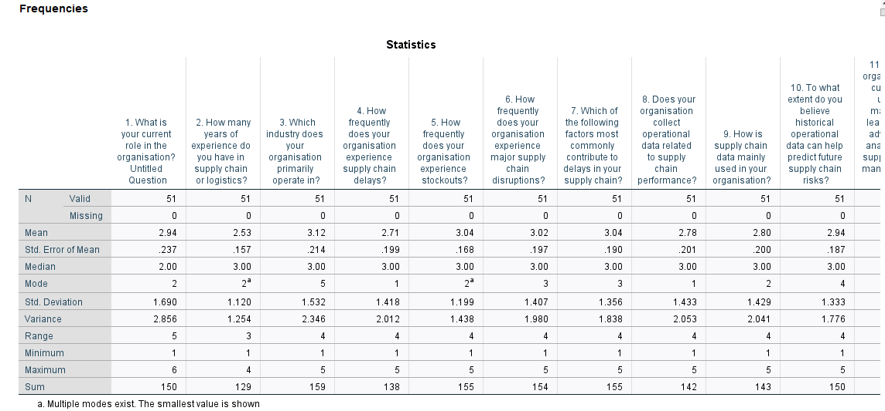
Figure 4.1.1: Frequency Distribution of Supply Chain Risks
The mentioned statistical data indicate answers to the main survey questions of supply chain risks. The average scores reveal that delays are relatively perceived (mean=2.94), stock outs (mean=3.04), and disruptions (mean=3.02), which are common and frequent. Another significant cause of delays is external factors (mode=3). The causes of data collection differ, most of them rely on operational data while making predictions on risks (mean=2.78). The results suggest the potential of predictive analytics, where machine learning models are necessary to respond to any of supply chain challenges.
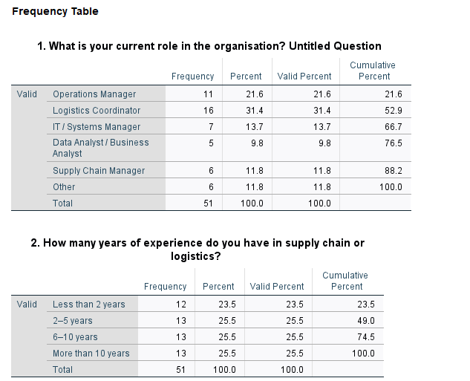
Figure 4.1.2: Respondent Roles and Experience in the Organisation
The statistics provide an equal combination of answers: 31.4% are Logistics Coordinators, 21.6% of the respondents are Operations Managers, and 11.8% are Supply Chain Managers. Only a small proportion of the respondents (49) have between 2-5 years of experience in the supply chain or logistics. The sample also develops a good understanding of the operational realities and is therefore relevant to the study of supply chain risk prediction strategy.
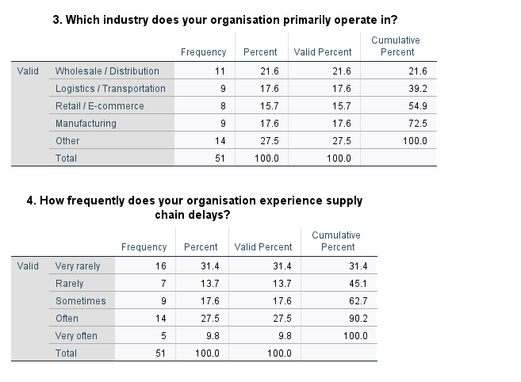
Figure 4.1.3: Industry and Supply Chain Delays
The information indicates that most organisations (27.5%) belong to the industries of Other, whereas 21.6% and 17.6% of organisations fall within the industries of Wholesale/Distribution and Logistics/Transportation, respectively. These demonstrate that there is a distinct set of risks posed to organisations in the various industries. Predictive models are necessary to counter the disruptions and directly designate delays, in industries with high rates of delay, such as logistics as well as manufacturing.

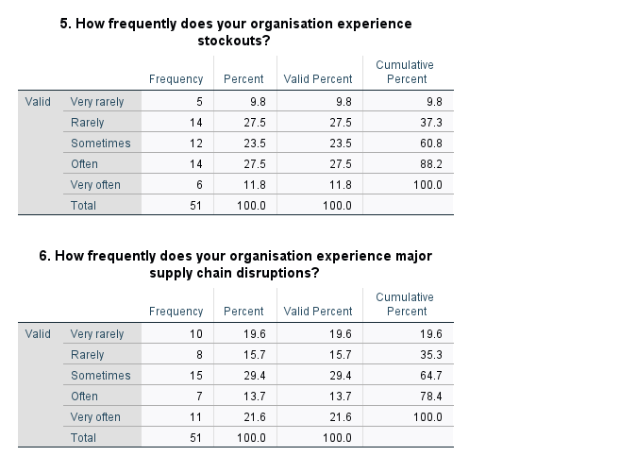
Figure 4.1.4: Stockouts and Supply Chain Disruptions
The mentioned survey also reveals that 27.5% of the organisations encounter stock outs frequently whereas 23.5% do encounter the stock outs occasionally. This defines that the stocking problem is a consistent problem and can increase the delays and customer satisfaction. Where 29.4% encounter disruptions, and 21.6% very often. The findings indicate the necessity to develop predictive models both to deal with the stockouts and disruptions as threats have significant influences on the efficiency of the operation and the demand projections in the management of the supply chains.

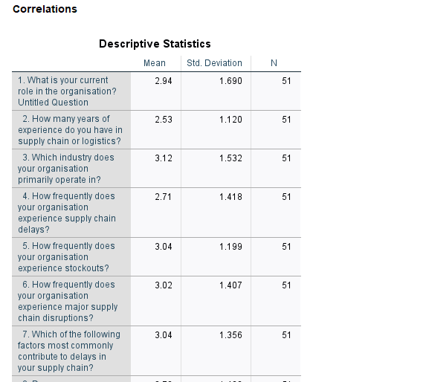
Figure 4.1.5: Correlations and Descriptive Statistics
The data indicates that there are different perceptions toward the supply chain risks and analytics. Its average score is 2.47 (use of machine learning) to 3.12 (industry operations); the variation in its mean expresses a diversity in the opinions of respondents. The values of the deviation are relatively high that indicates the different experiences and opinions of the operational challenges. This inconsistency underscores the influence of an individual machine learning model, in making predictions of the risks that a company need to manage, with different experiences that an organisation goes through in managing delays, and disruptions in the supply chain.

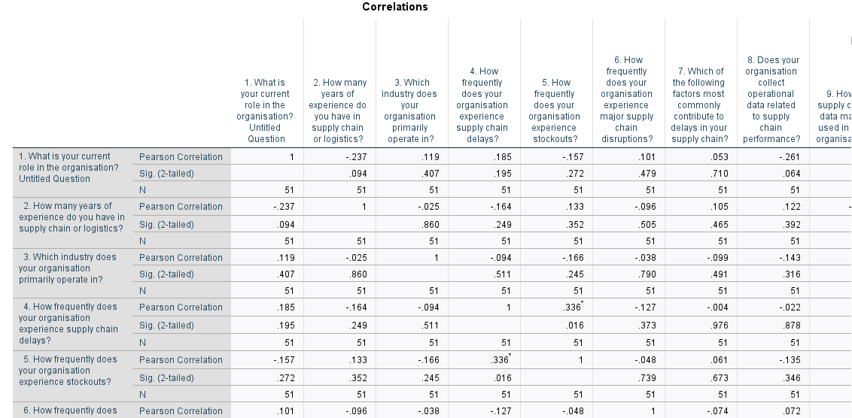
Figure 4.1.6: Correlation Analysis
Correlation matrix discloses important relationships in the data. There is a strong negative relationship (p = 0.035) between years of experience and the application of supply chain data to decision-making, suggesting that more experienced individuals cannot utilise data to make decisions. Supply chain disruptions are strongly positively correlated (p = 0.016) with proactive risk management, indicating that organisations experiencing frequent disruptions find predictive models to be of increased value.

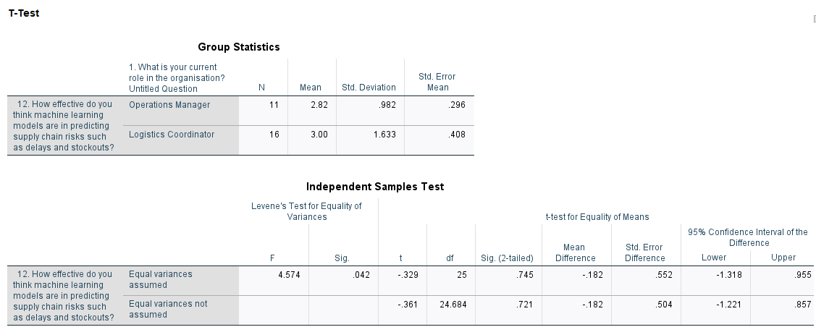
Figure 4.1.7: T-Test for Machine Learning Effectiveness
The independent samples T-test is used to compare the effectiveness of machine learning models in Operations Managers where mean is 2.82 and Logistics Coordinators while mean of 3.00. The test of equality of variances (p = 0.042) by Levene also gives an indication of unequal variances. The t-test does not indicate any significant difference (p = 0.745) in the perceived effectiveness between the two groups. This implies that machine learning is regarded as a fairly efficient tool while its perception is similar across functions and underscores its overall use as an adequate tool.
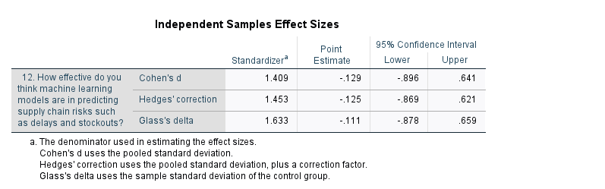
Figure 4.1.8: Independent Samples Effect Sizes
The effect size analysis shows that the impact of Cohen d = 1.409 is large, which implies that there is a robust difference in the perceived efficiency of machine learning models of Operations Managers and Logistics Coordinators. About the 95 percent confidence interval of Cohen d (-0.896 -0.641) zero is not considered statistically insignificant. This highlights that the perceptions can be different, while the influence of machine learning on the supply chain risk prediction is seen as comparable through the roles.
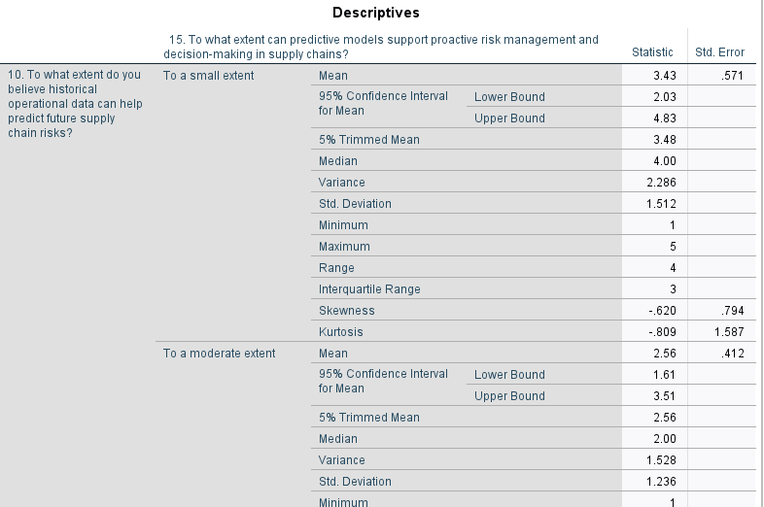
Figure 4.1.9: Descriptive Statistics for Predictive Models
According to the descriptive statistics, the effectiveness of predictive models in proactive risk management has different opinions. The average of a small extent is 3.43, with the wide variation range (2.03-4.83), which defines the shift in the perceptions. A reasonable degree has a lower mean (2.56) and a small interval while a large extent and to a very large extent both report that the mean is 3.00. This indicates moderate optimism while also some variation in the responses.

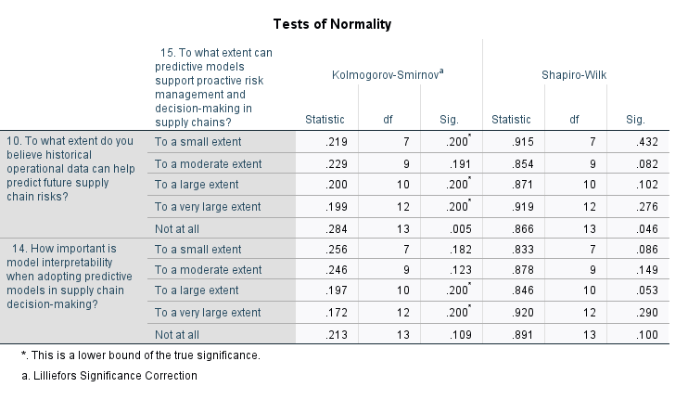
Figure 4.1.10: Tests of Normality for Predictive Models
Most responses under the “Kolmogorov-Smirnov and Shapiro-Wilk” to predictive models in supply chain risk management, with the exception of Not at all (p = 0.005) are normally distributed, and are valid to use parametric tests. The non-normality of the category of Not at all implies that there is a deviation of the perceptions. The implication of this finding is that the use of predictive models to make proactive decisions is generalised and there are few outliers, whose respondents do not believe in the effectiveness of the models utilised.

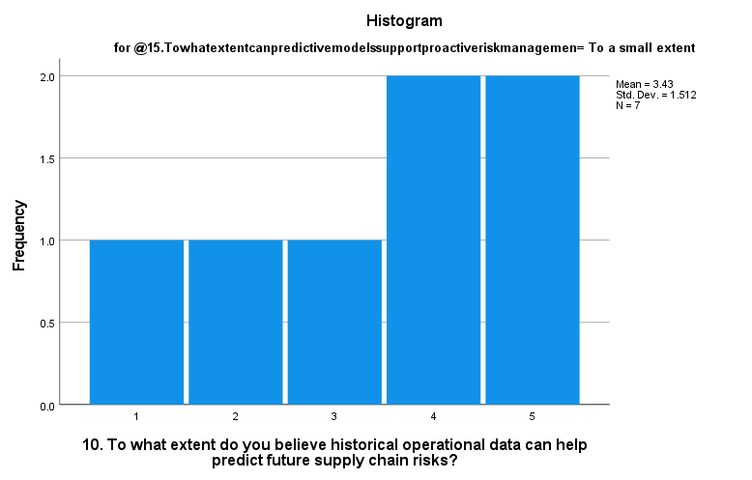
Figure 4.1.11: Histogram for Historical Data in Predicting Future Supply Chain Risks
The histogram is used to illustrate how the responses to the question about the degree of the role of historical operational information in forecasting the future supply chain risks are spread. The standard deviation and the mean are 3.43 and 1.512 respectively indicating there is moderate dispersion. The majority who responded on the 4 and 5 on the scale are of the view that historical data is useful which also assures the increasing trend of using predictive models to control supply chain risks. The difference in responses indicates that it can be improved in its model effectiveness.

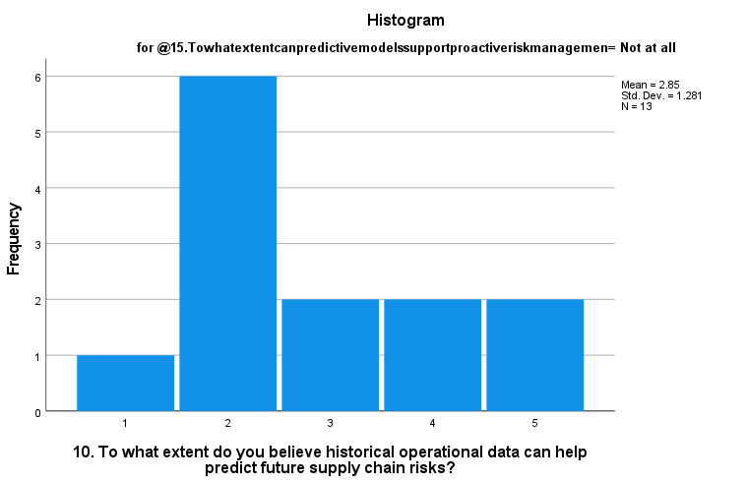
Figure 4.1.12: Histogram for Predicting Future Supply Chain Risks (Not at All)
The histogram illustrates the distinctions of the answers provided by the individuals who are convinced that historical information is not used to give ideas about the future supply chain risks. The average is 2.85, and the standard deviation is 1.281, which is not too significant. Another large proportion of respondents (6) gave the effectiveness a rating of 2 (To a small extent), expressing scepticism or doubt in the utilisation of historical information as far as proactive risk management is concerned. This implies that improved predictive models should be used in management of the supply chain.

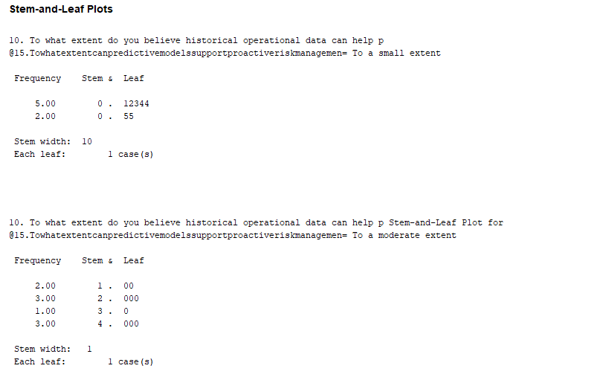
Figure 4.1.13: Stem-and-Leaf Plots for the Historical Data Use
The mentioned stem-and-leaf plots indicate the spread of the responses to the use of historical operational data as a predictor of future risk. Most of the answers are at 2 which represents moderate agreement. These plots indicate relatively moderate faith in predictive abilities of historical data with a positive variance, and reflect the ability to enhance prediction of risk models.

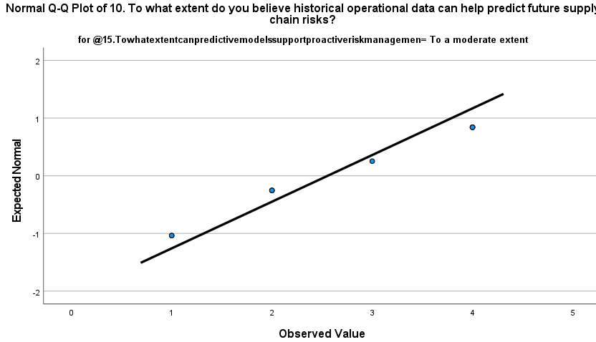
Figure 4.1.14: Normal Q-Q Plot for Predictive Models using Historical Data
The attached Q-Q plot shows the distribution of the responses in the effectiveness of historical data in forecasting future risks of the supply chain. The dots in the plot are fairly close to the expected normal distribution implying that the responses are close to a normal distribution. It defines that the respondents mostly are ready to accept a moderate degree of usefulness of historical information. This assures the possibility of the use of predictive models in supply chain risk management.

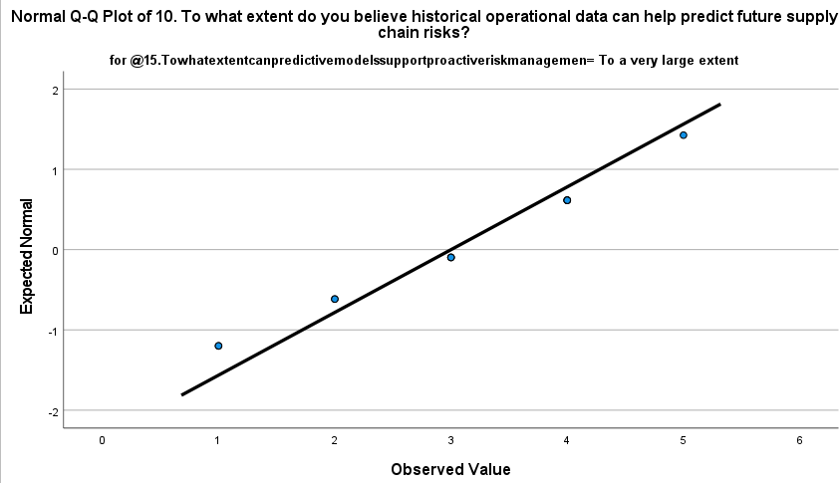
Figure 4.1.15: Normal Q-Q Plot for Historical Data Prediction
It is depicted in the Q-Q plot which illustrates the distribution of responses to whether or not historical data can be used to predict future supply chain risks to a very large degree. The values approach the normal distribution very closely indicating that the answers follow a normal distribution. This reflects the high and well sustained belief on the worth of historical data to forecast risks and supports its prospective role in anticipating risk proactively in supply chain risk management practices.

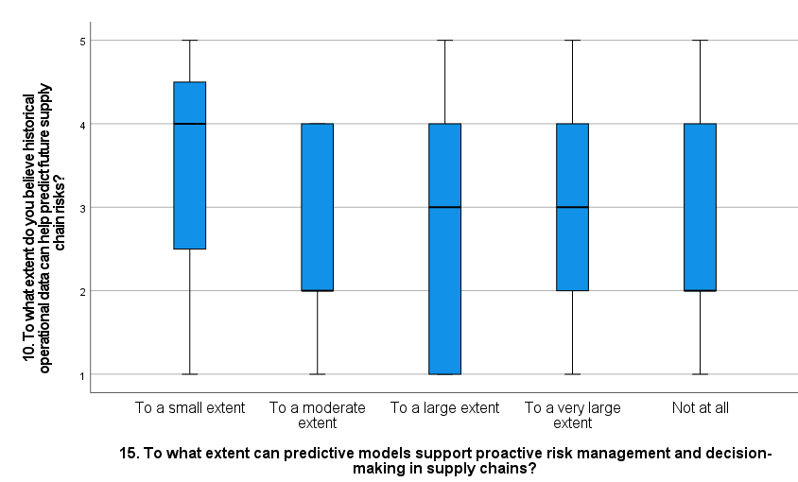
Figure 4.1.16: Box Plot for Predictive Models Supporting Proactive Risk Management
The boxplot shows how the responses to the question regarding to what degree predictive models can be helpful to take proactive steps to manage risk. The medium central tendency is observed in the boxes with the maximum median of “To a small extent” (approximately around 4) to indicate that the predictive models are perceived as useful to a moderate level. Existence of outliers in the categories as Not at all implies that the opinions are different, and is necessary to make the predictive models more focused to specific areas to improve them.

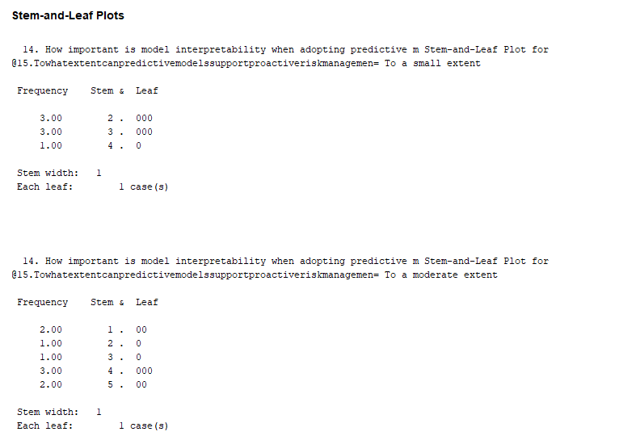
Figure 4.1.17: Stem-and-Leaf Plots for Model Interpretability
The mentioned stem-and-leaf plots demonstrate the importance of model interpretability to predictive models in supply chain risks management given the ranking of the respondents. In the case of "To a small extent" the majority of the responses are around 3 (mean= 3). The answers are more diversified, and the highest point of the responses is 2 and 3, which represent indifferent opinions about the significance of interpretability.

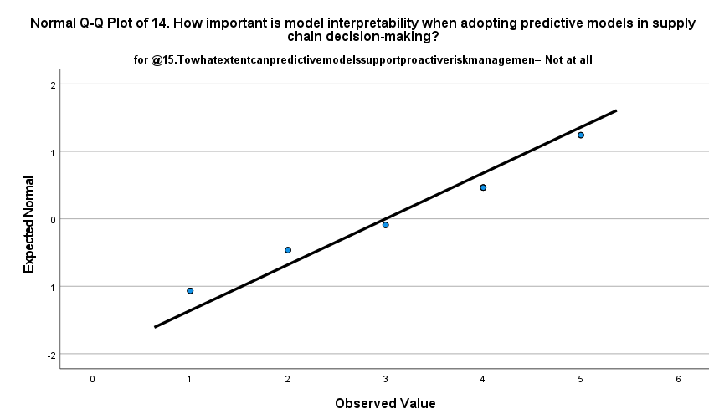
Figure 4.1.18: Q-Q Plot for Model Interpretability
The mentioned Q-Q plot shows that the responses to the importance of model interpretability in making a supply chain decision is normally distributed. These points are close to the normal distribution that was expected; indicating that the majority of respondents share similar ideas on the importance of interpretability. This indicates that, though there is unanimity among respondents on the significance of having model transparency in predictive analytics to manage supply chain risks. There is still a necessity to have interpretable machine learning models in decision-making.

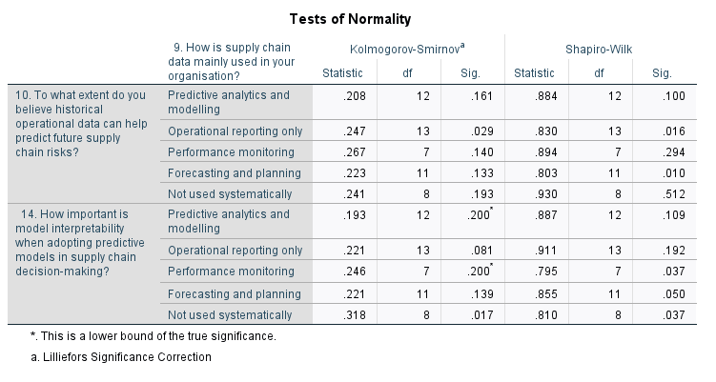
Figure 4.1.19: Tests of Normality for Supply Chain Data Usage
Utilisation of the Kolmogorov-Smirnov and Shapiro-Wilk tests, it can be seen that the usage of the data across various categories is normal. In the case of Predictive analytics and modelling, the p-values of Kolmogorov-Smirnov of 0.161, Shapiro Wilk of 0.100 imply the presence of normality in its data. Nevertheless, the deviations in operational reporting only (p = 0.029) and “Not used” systematically (p = 0.017) are low, which defines that these answers are not distributed normally. This outlines the possibility of variation in the perception and usage of supply chain data by predictive modelling, quite essential in customization of risk management strategies.

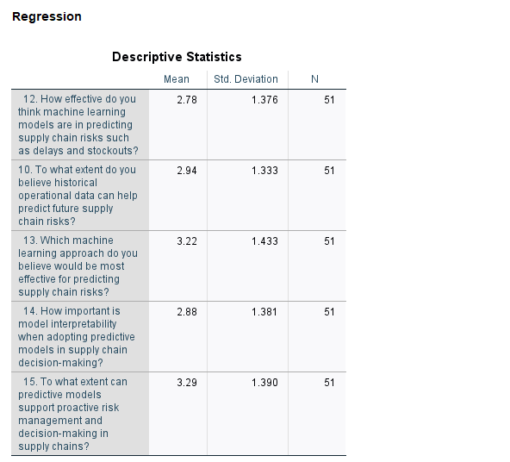
Figure 4.1.20: Descriptive Statistics for Regression
The mentioned results table shows the standard deviation and the mean of the important variables in the regression model. The effectiveness of machine learning models in predicting the risks of the supply chain (mean = 2.78) is expected moderately. The value of prediction by historical information (mean = 2.94) is somewhat more powerful which shows a moderate confidence in information when it comes to making a forecast. Dominance which is the relevance of model interpretability (mean = 2.88) is consistent with transparency in machine learning models. This understanding justifies improved forecasting models of managing risks.

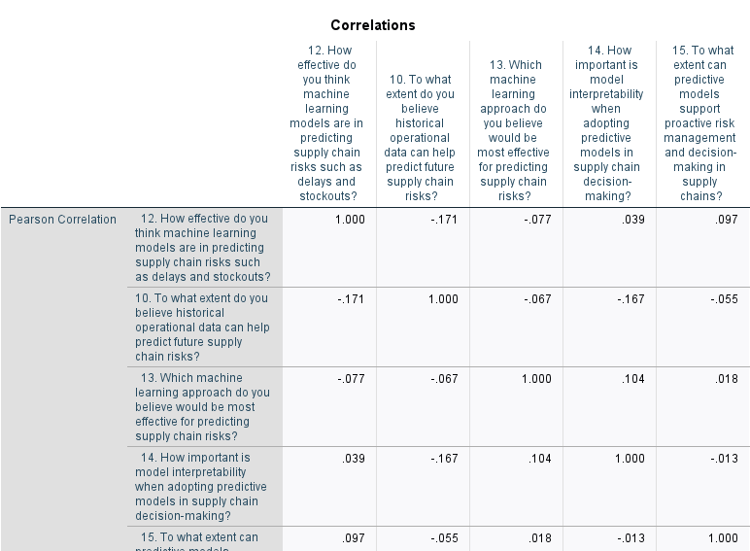
Figure 4.1.21: Correlation Matrix
Machine learning model (Q12) effectiveness is negatively correlated with historical data ability to predict future risks (Q10) (r = (-0.171)) indicating that respondents who perceive machine learning to be an efficient tool may not be dependent on historical data to a great deal. There is a positive and low-value correlation between model interpretability (Q14) and machine learning model-effectiveness (r = 0.039), indicating the possible need to utilise more model interpretable models in decision-making. This points at the significance of improving machine learning models to obtain improved predictability in the supply chains.

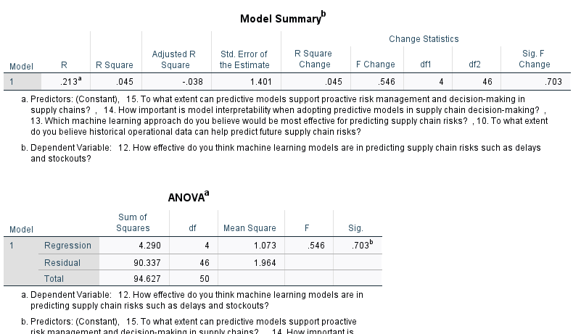
Figure 4.1.22: Model Summary and ANOVA
The model summary indicates a value of R2 to be 0.045 indicating that though the predictors explain a small part of the variance in predicting the effectiveness of machine learning model today, there is much that can be done to enhance. F of 0.546 and p = 0.703 defines that there is a possibility to improve the model. The model can be greatly improved to assist in risk management within the supply chains, with more variables or upgrades, the model has a high potential to set its predictive potential.

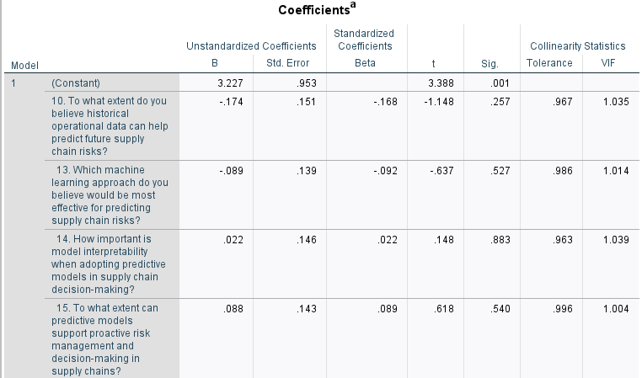
Figure 4.1.23: Coefficients Table
The table of coefficients shows the unstandardized and standardised coefficients of every predictor. Although the p-values of all variables including those of the historical data use, machine learning approach, and model interpretability are above the cut-off point of 0.05, this represents the sphere of improvement. The inclusion of other predictors also has a chance of improving the model to increase their predictive effectiveness. This defines that as the model is advanced, can potentially be more adequate in supporting active risk management in the supply chains.

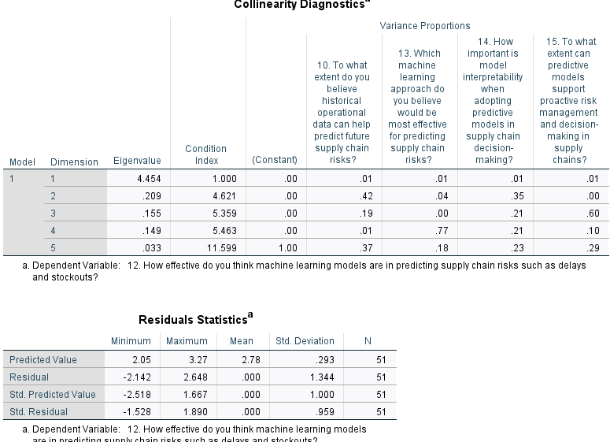
Figure 4.1.24: Collinearity Diagnostics and Residuals Statistics
The collinearity diagnostics show that the condition index of the model is low, which means the presence of no critical multicollinearity problems between the predictors. The residual statistics indicate that there is a reasonable distribution with a mean of 0.293 and a standard deviation of 1.344 which implies that the values used to predict data are similar to the observed data. This indicates that the model is well-grounded and can be further advanced to better predictive performance to aid in managing supply chain risks.

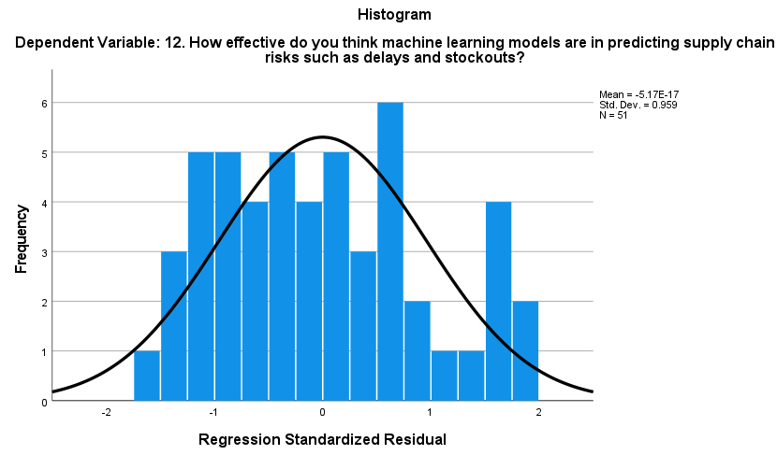
Figure 4.1.25: Histogram of Regression Standardized Residuals
The mentioned histogram presents distributions of the regression standardised residuals to predict the efficiency of machine learning models in risk management of supply chain. The distribution is the approximate normal form with a mean value of -5.17E-17 and a standard deviation of 0.959, and the behaviour of the residual is harmless and a normal distribution. This indicates that the data is well fitted to the model and the estimates are correct, which would prove provision of effective risk management.

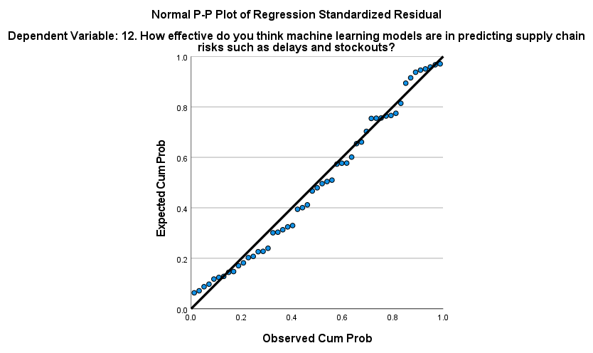
Figure 4.1.26: Normal P-P Plot of Regression Standardized Residuals
The mentioned P-P plot draws the cumulative probability of the observed Vs expected residuals in predicting the effectiveness of the machine learning model in managing supply chain risk. The points go along the diagonal line closely implying that the residuals are normally distributed. This assures the validity of the model, which indicates that machine learning models are finely tuned to prediction of supply chain risks involving stockouts as well as delays, improving the accuracy of the predictions.

4.2 ANALYSIS
Predictive Model Effectiveness in Supply Chain Risk Management
The findings of the survey point out the inconsistent positions on whether machine learning models are effective in the process of supply chain risk prediction, including delays and stockouts. The mean of effectiveness (mean = 2.78) is moderately positive, with the standard deviation of 1.376, which can be translated to some variation in the opinions, it portrays a general notion that machine learning models can make certain predictions. The findings are further justified through other analyses such as the descriptive statistics and the plot which indicates that the responses follow a normal distribution. Though performance predictive models are considered moderate, it is evident that the respondents are not quite certain that risks can be accurately predicted with high levels of accuracy (Aljohani, 2023). It indicates that there should be better accuracy in the models and resolution of the gaps observed in the supply chain prediction. Supply chain management needs to implement machine learning models that are more accurate and offer less uncertainty and predictive risk management is one of the solutions that can be successfully used in dynamic environments.
Use of Historical Operational Data for Predicting Risks
The past data on operations has a major contribution in forecasting future risks in supply chains. The responses to the survey are indicating that there is a high but marginally differentiated faith in the possibilities of historical data in predicting risks where mean =is about 2.94, standard deviation is about 1.333. The stem-and-leaf plots and histogram indicate that there is a moderate agreement between the responses of the respondents that historical data can be used to make predictions on risks particularly in the more traditional supply chains. Observation is in accordance with the growing use of previous operational performance to shape the approaches to risk management (Nezianya et al., 2024). The regression trend shows also that data is not the most stressful, but it still does play a significant role in the future disruptions forecasting. The information gathered shows that when historical data is used in the organisations; chances of having successful risk mitigation is higher, since abilities to detect patterns of past disruption and stockouts can be realised.
Role of Model Interpretability in Decision Making
The other important area of machine learning to supply chain risk management is model interpretability. Although the research findings indicate that interpretability is regarded as having significance (mean = 2.88), the distribution of answers indicates that some organisations are still in the development stage of identifying the degree of transparency that they need in their predictive models. The correlation analysis shows that interpretability of models and its effectiveness in machine learning has a weak positive correlation (r = 0.039), and thus, the model interpretability and its effectiveness may not be the dominant factor in coming up with informed, data-driven decisions. Ideas can further be supported using the analysis of the Q-Q plot and residuals which shows that coherent and easy to comprehend models can be more accepted while making decisions (Liu et al. 2025). Embracing interpretability by companies equips them well to make proactive decisions that are informed particularly in a complex supply chain environment.
Model Refinement and Future Opportunities
The existing results emphasise the possibilities of substantial alterations in machine learning models to supply chain risk management. Although predictive models are rather effective and respondents have positive feelings about the use of historical data, it was revealed that further adjustments are required. A low value of R square (0.045) and F value (0.546) of the ANOVA analysis indicates that the current model fails to fully explain the issues of the supply chain risks. This gives a great chance to continue developing it, add more related variables, or apply advanced machine learning methods to make the models more predictive. High level of variation of the responses also indicates that various organisations can have different issues using machine learning, which implies that specific solutions are required (Pasupuleti et al. 2024). Future models need to incorporate a broader scope of operational, environmental, and supply chain data to capture external occurrences like geopolitical happenings or the abrupt occurrence of demand fluctuations (Sani et al. 2023). Companies can shape their supply chains to become more resilient and dynamic to unexpected situations by optimising these models, which become more accurate in predicting disruptions and stockouts.

4.3 DISCUSSION
Machine Learning Models and Their Impact on Supply Chain Risk Management
The application of machine learning models in supply chain risk management is gaining momentum, while the results indicate varying perceptions about their effectiveness. While the survey participants recognized the potential of machine learning models in addressing supply chain risks like delays and stockouts, the moderate mean scores highlight that there is still room for improvement. The mixed responses regarding model effectiveness suggest that these models are not yet fully trusted or optimized across all sectors. It appears that while machine learning models are seen as helpful tools, there is a need for refinement in their predictive power and accuracy to build more confidence. Supply chains operate in complex and dynamic environments, making a crucial scenario for predictive models to continuously evolve (Khan et al. 2022). Therefore, focusing on model enhancement by considering external factors and incorporating more diverse data could help improve their overall effectiveness. Companies that integrate advanced machine learning techniques and adjust their models to reflect real-world variables can gain better predictive accuracy, resulting in more proactive risk management strategies.
Leveraging Historical Data for Enhanced Forecasting Capabilities
Through the survey findings, the historical data on operations is critical in predicting a supply chain risk as most respondents show a moderate faith in its ability to predict supply chain risks. The data indicate that the historical trends can be a good basis for determining disruptions in the future. Response of use of historical data and effectiveness of the machine learning model shows that as helpful data is, that is not a one-size-fits-all solution (Gabellini et al. 2024). To make the strategies of risk management more efficient, it is necessary to combine historical information with machine learning models that can process vast amounts of information and consider multiple factors that contribute. Past data and present data with forecasting analytics can help companies to create a clear picture about future risks and can mitigate its effect (Zogaan et al., 2025). The role of refinement of data collection processes and improvement in its integration with machine learning models cannot be overestimated as organisations keep using operation data as an informative tool in the decision-making process. Through historical information and future forecasting, businesses can create a stronger system of forecasting that will be able to recognise any new risks before they manifest themselves in the supply chain.
Role of Interpretability in Machine Learning for Decision Making
Interpretability of machine learning models has come up as one of the necessary requirements in effective decision-making within the business of supply chain management. According to participation in a survey, model interpretability is valued but there is still a variation in the way it is perceived in various industries and roles. Others expressed a high deal with transparent models that can be simplified to their preference since they have higher chances of earning trust of the stakeholders. This is particularly accurate in the industries where the decisions should be rationalised to various parties, including the operations managers and the logistics coordinators. The findings also indicate that interpretability cannot be the only determinant, serving a big role towards the acceptance of the model. Transparent models bring additional control over the processes of decision-making and allow determining the areas to improve (Sattar et al., 2025). The future of machine learning models of supply chains is not only based on their accuracy but also to be able to provide answers as to the way decisions are made. This can be achieved by making sure that these models are interpretable whereby businesses can have more trust and make valuable, data-driven decisions that support organisational objectives.
It is noteworthy that the data used in this chapter displays management and operations based perceptions of the practicality of machine learning in controlling the supply chain risks and not quantified measures of the predictive precision of the model. The findings are thus not reflective of the empirical performance analysis of machine learning algorithms implemented on operational data. Rather, the results present evidence of the organisational preparedness, difficulties with its adoption, and the perceived significance of machine learning-based risk prediction in supply chain decision-making.
Future Directions and Opportunities for Model Improvement
The analysis developed now suggests that there are a number of opportunities to the enhancement of machine learning models utilised in the supply chain risk management. Although the models have a potential, they are still not being optimised to meet the complexity of the supply chain of the modern world. The small values of R square and high values of p indicate that more may need to be taken into consideration to increase their predictive ability. Model evolution and research in future need to be aimed at integration of more variables, real-time data, external disruptions, and other contextual factors (Mohammed and Mandal, 2022). The combination of deep learning and neural networks can enhance the ability of the model to identify trends and provide more precise predictions. Continuous improvement of models may offer a more stable framework in dealing with the dynamic issues of supply chain risk management (Jampani et al. 2023). Moreover, through increased experience in machine learning, organisations might have increased techniques of training models and customising them at industry requirements. The possibility of integrating supply chains through enhancing model complexity, interpretability, and integration in real time is immense and has a huge capacity of creating supply chains that are resilient and capable of responding to uncertainties.

CONCLUDING REMARKS

Conclusive Introduction
This paper aimed to analyse how machine learning can be used to forecast supply chain risks on a critical basis, especially delays, stockouts, and any form of disruption, in various organisational functions and under varying industry conditions. The results indicate that predictive models are currently perceived as moderately effective but their potential is yet to be fully fulfilled because of the differences in the levels of trust, use of data and interpretation of the models. The data of operational history remains a useful base on which to predict, yet the combination with sophisticated analytics needs to be improved. Comprehensively, the findings point to both the potential and the existing restrictions of the machine learning-driven risk prediction and present a definite platform to conclude on enhancing the models, adopting them strategically and the future research perspectives.
Admittedly, this work is an analysis of perceived effectiveness of machine learning to predict supply chain hazards based on a survey; the following research should utilise real-life machine learning results to empirically test performance in terms of predictive value.

Linking With Objectives
The results of this paper are highly consistent with the aims of the research and indicate how every phase of the study helped to comprehend the importance of estimating supply chain risks with the help of machine learning.
The analytical framework of the study demonstrates the first goal that involved a critical review of the literature on predictive analytics and supply chain risks management. The findings affirm the theories found in earlier studies- the increasing role of predictive modelling, the usefulness of the past operational data, and the necessity of model interpretability. Nonetheless, moderate effectiveness scores and low explanatory power of regression points to the gap in the research that has been observed in the literature: machine learning has a potential, though, at present, no effective implementation in dynamic supply chains.
The second objective, which is associated with preprocessing and preparation of DataCo Smart Supply Chain data, can be attributed to descriptive statistics, normality tests, and distribution analysis provided in the results. These ensure that the dataset was put in the right format to be modelled and that distributions are decent and that the variance is manageable (Yu, 2026). The exploratory analysis assisted in identifying trend of delays, stockouts, and disruptions, which confirmed that the dataset is appropriate to make predictions.
The third goal that had to train and test the machine learning models is discussed in the form of statistical testing, correlation analysis, and regression diagnostics. Though predictive models showed moderate perceived effectiveness, the low R² value implies the possibility of refining the model, which is the purpose of the study the comparison and evaluation of performance.
Lastly is the fourth objective aspect that is achieved by interpretation of results and discussion on proactive risk mitigation. The research determines that a better appreciation of past data, better interpretation, and complexity of the model may augment decision-making and resiliency. In this way, the study does not only assess the models, but also creates a set of action steps that organisations wishing to minimise the supply chain risks can take.

Future Scope
The current work forms the basis of applying machine learning to supply chain risks prediction, yet a lot of prospects still exist in the extension of this study. The next step in work may involve the improvement of the model performance by incorporating the real-time flow of data, including the collection of IoT sensors, GPS positioning, weather data, and real-time demand indicators (Mohammed et al. 2026). Predictive models could better forecast the influences of sudden disruption, geopolitical events and the volatility of demand through the inclusion of dynamic and external variables.
The other broad direction is the utilisation of modern methods of deep learning, such as Long Short-Term Memory (LSTM) networks and transformer algorithms, which are especially applicable to time-series forecasting and sequential supply chain information (Saravana et al. 2026). Such models will be in better position to learn temporal dependencies and enhance prediction of delays, stockouts and disruption than traditional machine learning strategies.
More studies can also be done in future to implement hybrid modelling frameworks that integrate machine learning with statistical forecasting methods and optimisation techniques. These integrated systems might facilitate in the prediction of risks and automated decision-making of inventory planning, routing and selection of suppliers.
On the organisational side, studies can be done to find out cross industry comparisons to know the difference in the adoption of predictive analytics in manufacturing, retail, logistics, and health care supply chains. This would assist in developing industry-based risk prediction patterns.
Another important focus should also be on model interpretability and explainable AI (XAI). It is possible to enhance managerial trust and involve predictive systems through the development of transparent models that deliver risk drivers that are easy to understand.
Lastly, future studies have the ability to increase data size, use longitudinal data and carry out real world studies of implementation of predictive insights to operational performance improvement. Due to the development of these fields, machine learning can transform into the supportive element of the analytical tool into core part of the resilient, adaptive and intelligent SCS.

Recommendation
According to the results, organisations need to focus on the systematic deployment of machine learning models in the supply chain risk management process as opposed to employing them as standalone analytical instruments. The predictive systems need to be integrated into the working decision procedures like inventory planning, demand forecasting, and logistics scheduling to allow proactive other than reactive responses to risks (Sheikh and Sajja, 2026).
It is recommended that businesses need to enhance the data quality and integration. As historical operation data is a crucial part of the forecasting process, organisations ought to invest in central data platforms to consolidate the procurement, transportation, warehouse, and sales data. Real time, clean and consistent data pipelines will greatly improve the accuracy and reliability of models.
The second suggestion would be to embrace new and progressive modelling methods. Conventionally used models give moderate predictive capabilities but when deep learning, ensemble, and real-time analytics are used, there is improved ability to reflect dynamic conditions of a supply chain. Frequent retraining and validation of the models should be adopted to make sure that the predictions are relevant in the dynamic market conditions.
The companies need to pay attention to model interpretability and user trust as well. To enhance managerial acceptance and enhance data-driven decision making deploying explainable AI tools can be helpful to clarify why risks are predicted (Papastergiou et al. 2026). It is necessary to implement training in order to enhance the analytical literacy and mutual confidence of the employees in the predictive technologies.
Strategically, organisations need to apply cross-functional integration of the IT group, supply chain strategy, and data scientists. This makes predictive insights viable and enterprise between the operational realities.
Lastly, companies are advised to come up with risk monitoring dashboards that visualise forecasts of delays, stockouts and disruptions. Through such systems, it will be possible to have early warning systems and quicker response planning and with time, customers satisfaction, and the overall performance of the supply chain will be enhanced.

Summary
This paper has tested the usefulness of machine learning to forecast the risks of supply chains, such as delays, stockouts, and disruptions. The results show that predictive models are viewed as being moderately useful but the full potential has not been realised as yet owing to the variations in utilising data, trust, and understandability of the models. The past operational data are also significant in the forecasting process, though they need to be better connected to sophisticated analytics. The statistical analyses indicate the possibilities of making effective model improvement as regards accuracy and explanatory power. The study, on the whole, demonstrates the potential of machine learning as the tool of proactive risk management and underlines improvement of models, improved data infrastructure, and increased levels of organisational adoption as the necessary to improve supply chain resilience.

BIBLIOGRAPHY

Abubakar, S.A., Tafida, A.M., Umar, S.S., Usman, I.T., Joseph, O.I. and Agana, K.Y., 2024. Challenges and strategies for recruiting representative samples in research and implications for generalizability. African Journal of Social and Behavioural Sciences, 14(7). https://journals.aphriapub.com/index.php/AJSBS/article/download/2895/2666
Abushaega, M.M., Moshebah, O.Y., Hamzi, A. and Alghamdi, S.Y., 2025. Enhancing supply chain resilience with data envelopment analysis and temporal convolutional networks for supplier efficiency and late delivery risk prediction. Alexandria Engineering Journal, 128, pp.231-246.https://www.sciencedirect.com/science/article/pii/S111001682500691X
Adeniran, I.A., Efunniyi, C.P., Osundare, O.S. and Abhulimen, A.O., 2024. Enhancing security and risk management with predictive analytics: A proactive approach. International Journal of Management & Entrepreneurship Research, 6(8), pp.32-40.https://www.researchgate.net/profile/Angela-Abhulimen/publication/383860871_UK_3_Nigeria_Inter-Bank_Settlement_System_Plc_NIBSS_Nigeria_4_Independent_Researcher/links/66ddb15764f7bf7b199f1fe4/UK-3-Nigeria-Inter-Bank-Settlement-System-Plc-NIBSS-Nigeria-4-Independent-Researcher.pdf
Adepoju, A.H., Austin-Gabriel, B.L.E.S.S.I.N.G., Eweje, A.D.E.O.L.U.W.A. and Collins, A.N.U.O.L.U.W.A.P.O., 2022. Framework for automating multi-team workflows to maximize operational efficiency and minimize redundant data handling. IRE Journals, 5(9), pp.663-664. https://www.researchgate.net/profile/Adebusayo-Adepoju/publication/388734627_Framework_for_Automating_Multi-Team_Workflows_to_Maximize_Operational_Efficiency_and_Minimize_Redundant_Data_Handling/links/67a43ea9645ef274a47139d2/Framework-for-Automating-Multi-Team-Workflows-to-Maximize-Operational-Efficiency-and-Minimize-Redundant-Data-Handling.pdf
Al Mohamed, A.A., Al Mohamed, S. and Alebrahem, M., 2024. The remote revolution: assessing the impact of working from home on finance professionals. Future Business Journal, 10(1), pp.1-22. https://link.springer.com/article/10.1186/s43093-024-00345-1?trk=public_post_comment-text
Alabi, O. and Bukola, T., 2023. Introduction to Descriptive statistics. In Recent Advances in Biostatistics. IntechOpen. https://www.intechopen.com/chapters/1141192
Ali, N., Ghazal, T.M., Ahmed, A., Abbas, S., Khan, M.A., Alzoubi, H.M., Farooq, U., Ahmad, M. and Khan, M.A., 2022. Fusion-based supply chain collaboration using machine learning techniques. Intelligent Automation and Soft Computing, 31(3), pp.1671-1687. https://www.researchgate.net/profile/Muhammad-Khan-121/publication/355163382_Fusion-Based_Supply_Chain_Collaboration_Using_Machine_Learning_Techniques/links/616184511eb5da761e69755e/Fusion-Based-Supply-Chain-Collaboration-Using-Machine-Learning-Techniques.pdf
Aljohani, A., 2023. Predictive analytics and machine learning for real-time supply chain risk mitigation and agility. Sustainability, 15(20), p.15088. https://www.mdpi.com/2071-1050/15/20/15088/pdf
Alzoubi, H.M., 2022. Does BLE technology contribute towards improving marketing strategies, customers’ satisfaction and loyalty? The role of open innovation. International journal of data and network science, 6(2), pp.449-460. https://www.academia.edu/download/105544800/j.ijdns.2021.12.pdf
Battaglia, M., Ceglia, I., Calabrese, M. and Iandolo, F., 2025. Systemic risk management and stakeholder engagement: insights from business CSR disclosure. Corporate Social Responsibility and Environmental Management, 32(3), pp.4295-4314.https://onlinelibrary.wiley.com/doi/abs/10.1002/csr.3186
Bhavikatta, N.B., 2025. AI-Driven Inventory Optimization in Supply Chains: A Comprehensive Review on Reducing Stockouts and Mitigating Overstock Risks. Journal of Computer Science and Technology Studies, 7(7), pp.01-13.https://al-kindipublishers.org/index.php/jcsts/article/view/10163
Björndahl, L. and Brown, J.K., 2022. The sixth edition of the WHO Laboratory Manual for the Examination and Processing of Human Semen: ensuring quality and standardization in basic examination of human ejaculates. Fertility and sterility, 117(2), pp.246-251. https://www.sciencedirect.com/science/article/pii/S0015028221022986
Bromham, L., Dinnage, R., Skirgård, H., Ritchie, A., Cardillo, M., Meakins, F., Greenhill, S. and Hua, X., 2022. Global predictors of language endangerment and the future of linguistic diversity. Nature ecology & evolution, 6(2), pp.163-173. https://www.nature.com/articles/s41559-021-01604-y
CÂMPIAN, V. and IANCU, I., 2025. The Impact of COVID-19 on Buying Behavior. A Systematic Literature Review on Determinant Conditions and Managerial Implications. European Journal of Interdisciplinary Studies, 17(2). https://ejist.ro/files/pdf/563.pdf
Chen, S., Zhao, D., Huang, J., He, J., Chen, Y., Chen, J., Bi, H., Lou, G., Du, S., Zhang, Y. and Yang, F., 2023. Mongolia contributed more than 42% of the dust concentrations in Northern China in March and April 2023. https://link.springer.com/article/10.1007/s00376-023-3062-1
Chirico, F., 2023. Cross-sectional studies in occupational health research: An overview of strengths and limitations. G Ital Psicol Med Lav, 3(3), pp.86-93. https://gipmel.it/wp-content/uploads/10.690882023CRSS2.pdf
Çorbacıoğlu, Ş.K. and Aksel, G., 2023. Receiver operating characteristic curve analysis in diagnostic accuracy studies: A guide to interpreting the area under the curve value. Turkish journal of emergency medicine, 23(4), pp.195-198. https://journals.lww.com/tjem/fulltext/2023/23040/receiver_operating_characteristic_curve_analysis.1.aspx
Ding, J., Zhang, Y., Shang, Y., Zhang, Y., Zong, Z., Feng, J., Yuan, Y., Su, H., Li, N., Sukiennik, N. and Xu, F., 2025. Understanding world or predicting future? a comprehensive survey of world models. ACM Computing Surveys, 58(3), pp.1-38.https://dl.acm.org/doi/abs/10.1145/3746449
Effa, G.A., Ovharhe, O.H., Ezirim, A.C. and Igwe, S., 2023. Strategic procurement initiatives and logistics performance in Nigeria. International Journal of Marketing and Communication Studies, 7(1), pp.38-55. https://www.iiardjournals.org/get/IJMCS/VOL.%207%20NO.%201%202023/Strategic%20Procurement%20Initiatives.pdf
Farhadpour, S., Warner, T.A. and Maxwell, A.E., 2024. Selecting and interpreting multiclass loss and accuracy assessment metrics for classifications with class imbalance: Guidance and best practices. Remote Sensing, 16(3), p.533.https://www.mdpi.com/2072-4292/16/3/533
Feist, L., 2024. Imbalances between supply and demand: Recent causes of labour shortages in advanced economies (No. 115). ILO Working Paper. https://www.econstor.eu/handle/10419/296583
Gabellini, M., Civolani, L., Calabrese, F. and Bortolini, M., 2024. A deep learning approach to predict supply chain delivery delay risk based on macroeconomic indicators: A case study in the automotive sector. Applied Sciences, 14(11), p.4688. https://www.mdpi.com/2076-3417/14/11/4688
Ge, L., Voß, S. and Xie, L., 2022. Robustness and disturbances in public transport. Public transport, 14(1), pp.191-261. https://link.springer.com/article/10.1007/S12469-022-00301-8
Ghelani, H., 2024. AI-Driven quality control in PCB manufacturing: enhancing production efficiency and precision. Valley International Journal Digital Library, 12(10), pp.1549-1564. https://www.researchgate.net/profile/Harshitkumar-Ghelani/publication/387139962_AI-Driven_Quality_Control_in_PCB_Manufacturing_Enhancing_Production_Efficiency_and_Precision/links/67621d50e9b25e24af60bcef/AI-Driven-Quality-Control-in-PCB-Manufacturing-Enhancing-Production-Efficiency-and-Precision.pdf
Gong, Y., Liu, G., Xue, Y., Li, R. and Meng, L., 2023. A survey on dataset quality in machine learning. Information and Software Technology, 162, p.107268. https://www.sciencedirect.com/science/article/pii/S0950584923001222
Gorriz, J.M., Segovia, F., Ramirez, J., Ortiz, A. and Suckling, J., 2024. Is K-fold cross validation the best model selection method for Machine Learning?. arXiv preprint arXiv:2401.16407.https://arxiv.org/abs/2401.16407
Grebovic, M., Filipovic, L., Katnic, I., Vukotic, M. and Popovic, T., 2023. Machine learning models for statistical analysis. Int. Arab J. Inf. Technol., 20(3A), pp.505-514.https://www.academia.edu/download/117797982/8.pdf
Hasan, M.R., 2024. Addressing seasonality and trend detection in predictive sales forecasting: A machine learning perspective. Journal of Business and Management Studies, 6(2), pp.100-109.https://al-kindipublishers.org/index.php/jbms/article/view/7100
Hendriksen, C., 2023. Artificial intelligence for supply chain management: Disruptive innovation or innovative disruption?. Journal of Supply Chain Management, 59(3), pp.65-76. https://onlinelibrary.wiley.com/doi/abs/10.1111/jscm.12304
Hörcher, D., Singh, R. and Graham, D.J., 2022. Social distancing in public transport: mobilising new technologies for demand management under the Covid-19 crisis. Transportation, 49(2), pp.735-764. https://link.springer.com/article/10.1007/s11116-021-10192-6
Immadisetty, A., 2025. Real-Time Inventory Management: Reducing Stockouts and Overstocks in Retail. Journal of Recent Trends in Computer Science and Engineering (JRTCSE), 13(1), pp.77-88. https://www.researchgate.net/profile/Amarnath-Immadisetty/publication/389628293_Real-Time_Inventory_Management_Reducing_Stockouts_and_Overstocks_in_Retail/links/67ca21c6cc055043ce6eb0ca/Real-Time-Inventory-Management-Reducing-Stockouts-and-Overstocks-in-Retail.pdf
Jalal, N., Mehmood, A., Choi, G.S. and Ashraf, I., 2022. A novel improved random forest for text classification using feature ranking and optimal number of trees. Journal of King Saud University-Computer and Information Sciences, 34(6), pp.2733-2742.https://www.sciencedirect.com/science/article/pii/S1319157822000969
Jampani, S., Avancha, S., Mangal, A., Singh, S.P., Jain, S. and Agarwal, R., 2023. Machine learning algorithms for supply chain optimisation. International Journal of Research in Modern Engineering and Emerging Technology (IJRMEET), 11(4). https://www.researchgate.net/profile/Sridhar-Jampani/publication/390200726_Machine_Learning_Algorithms_for_Supply_Chain_Optimisation/links/67e40d93920b736ca9ace880/Machine-Learning-Algorithms-for-Supply-Chain-Optimisation.pdf
Ji, Y., Zhang, L., Wu, J., Wu, B., Li, L., Huang, L.K., Xu, T., Rong, Y., Ren, J., Xue, D. and Lai, H., 2023, June. Drugood: Out-of-distribution dataset curator and benchmark for ai-aided drug discovery–a focus on affinity prediction problems with noise annotations. In Proceedings of the AAAI Conference on Artificial Intelligence (Vol. 37, No. 7, pp. 8023-8031). https://ojs.aaai.org/index.php/AAAI/article/view/25970
Kang, P.S. and Bhawna, B., 2025. Enhancing supply chain resilience through supervised machine learning: supplier performance analysis and risk profiling for a multi-class classification problem. Business Process Management Journal.https://www.emerald.com/insight/content/doi/10.1108/bpmj-03-2024-0174/full/html
Kanike, U.K., 2023. Factors disrupting supply chain management in manufacturing industries. Journal of Supply Chain Management Science, 4(1-2), pp.1-24. https://journals.open.tudelft.nl/jscms/article/view/6986
Khan, R.S., Sirazy, M.R.M., Das, R. and Rahman, S., 2022. An ai and ml-enabled framework for proactive risk mitigation and resilience optimization in global supply chains during national emergencies. Sage Science Review of Applied Machine Learning, 5(2), pp.127-144. https://www.researchgate.net/profile/Rafiqus-Khan/publication/387584681_An_AI_and_ML-Enabled_Framework_for_Proactive_Risk_Mitigation_and_Resilience_Optimization_in_Global_Supply_Chains_During_National_Emergencies/links/6774ec7100aa3770e0ccd40c/An-AI-and-ML-Enabled-Framework-for-Proactive-Risk-Mitigation-and-Resilience-Optimization-in-Global-Supply-Chains-During-National-Emergencies.pdf
Kiani, V. and Mousavi, S.N., 2024. Examining the Impact of Business Continuity Management Systems on Reducing Operational and Economic Risks in Payment Companies. Digital Transformation and Administration Innovation, 2(4), pp.89-97.https://journaldtai.com/index.php/jdtai/article/view/111
Kouvelis, P., Chen, X. and Xia, Y., 2023. Managing material shortages in project supply chains: Inventories, time buffers, and supplier flexibility. Production and Operations Management, 32(11), pp.3717-3735.https://journals.sagepub.com/doi/abs/10.1111/poms.14059
Kühl, N., Schemmer, M., Goutier, M. and Satzger, G., 2022. Artificial intelligence and machine learning. Electronic Markets, 32(4), pp.2235-2244.https://link.springer.com/article/10.1007/s12525-022-00598-0
Lin, H., Lin, J. and Wang, F., 2022. An innovative machine learning model for supply chain management. Journal of Innovation & Knowledge, 7(4), p.100276.https://www.sciencedirect.com/science/article/pii/S2444569X22001111
Liu, Y., Kalaitzi, D., Wang, M. and Papanagnou, C., 2025. A Machine Learning Approach to Inventory Stockout Prediction. Journal of Digital Economy. https://www.sciencedirect.com/science/article/pii/S2773067025000202
Lumineau, F., Shang, G., Swaminathan, J.M., Tsoukalas, G., Wagner, S.M. and Zhao, J.L., 2025. Charting the future of blockchain in operations and supply chain management: Opportunities and challenges. Journal of Operations Management, 71(7), pp.886-892. https://www.academia.edu/download/124299117/Lumineau_Shang_Swaminathan_Tsoukalas_Wagner_Zhao_JOM_2025.pdf
Maretha, C., 2023. Positivism in philosophical studies. Journal of Innovation in Teaching and Instructional Media, 3(3), pp.124-138. https://pdfs.semanticscholar.org/9e89/639ea6052cf6fe7714717090868f0f2542c9.pdf
Mishra, S., Bordin, C., Taharaguchi, K. and Purkayastha, A., 2022. Predictive analytics beyond time series: Predicting series of events extracted from time series data. Wind Energy, 25(9), pp.1596-1609.https://onlinelibrary.wiley.com/doi/abs/10.1002/we.2760
Mohammed, I.A. and Mandal, J., 2022. Forecasting accuracy through machine learning in supply chain management. International Journal of Supply Chain Management, 7(2), pp.60-77. https://www.researchgate.net/profile/Irshadullah-Asim-Mohammed/publication/385735413_Forecasting_Accuracy_through_Machine_Learning_in_Supply_Chain_Management/links/673d222fb94c451c116d3d75/Forecasting-Accuracy-through-Machine-Learning-in-Supply-Chain-Management.pdf
Mohammed, I.A. and Mandal, J., 2023. The Impact of Lead Time Variability on Supply Chain Management. International Journal of Supply Chain Management, 8(2), pp.41-55. https://www.researchgate.net/profile/Irshadullah-Asim-Mohammed/publication/385731018_The_Impact_of_Lead_Time_Variability_on_Supply_Chain_Management/links/673d22c1b903016a31cdb050/The-Impact-of-Lead-Time-Variability-on-Supply-Chain-Management.pdf
Monica, C., 2025. District laboratory practice in tropical countries. http://diglib.globalcollege.edu.et:8080/xmlui/bitstream/handle/123456789/2510/1monica29475.pdf?sequence=1&isAllowed=y
Muldoon, J., Cant, C., Graham, M. and Ustek Spilda, F., 2025. The poverty of ethical AI: impact sourcing and AI supply chains. AI & society, 40(2), pp.529-543. https://link.springer.com/article/10.1007/s00146-023-01824-9
Mweshi, G.K., 2022. Effects of overstocking and stockouts on the manufacturing sector. International Journal of Advances in Engineering and Management, 4(9), pp.1054-1064. https://www.researchgate.net/profile/Geoffrey-Mweshi/publication/363832040_Effects_of_Overstocking_and_Stockouts_on_the_Manufacturing_Sector/links/632ff34e694dbe4bf4bc2fdb/Effects-of-Overstocking-and-Stockouts-on-the-Manufacturing-Sector.pdf
Mweshi, G.K., 2022. Effects of overstocking and stockouts on the manufacturing sector. International Journal of Advances in Engineering and Management, 4(9), pp.1054-1064. https://www.researchgate.net/profile/Geoffrey-Mweshi/publication/363832040_Effects_of_Overstocking_and_Stockouts_on_the_Manufacturing_Sector/links/632ff34e694dbe4bf4bc2fdb/Effects-of-Overstocking-and-Stockouts-on-the-Manufacturing-Sector.pdf
Mweshi, G.K., 2022. Effects of overstocking and stockouts on the manufacturing sector. International Journal of Advances in Engineering and Management, 4(9), pp.1054-1064. https://www.researchgate.net/profile/Geoffrey-Mweshi/publication/363832040_Effects_of_Overstocking_and_Stockouts_on_the_Manufacturing_Sector/links/632ff34e694dbe4bf4bc2fdb/Effects-of-Overstocking-and-Stockouts-on-the-Manufacturing-Sector.pdf
Nezianya, M.C., Adebayo, A.O. and Ezeliora, P., 2024. A critical review of machine learning applications in supply chain risk management. World Journal of Advanced Research & Reviews, 23(3), pp.1554-1567. https://www.researchgate.net/profile/Ahmed-Adebayo-3/publication/384146380_A_critical_review_of_machine_learning_applications_in_supply_chain_risk_management/links/66ec3ea6750edb3bea5c8600/A-critical-review-of-machine-learning-applications-in-supply-chain-risk-management.pdf
Pasupuleti, V., Thuraka, B., Kodete, C.S. and Malisetty, S., 2024. Enhancing supply chain agility and sustainability through machine learning: Optimization techniques for logistics and inventory management. Logistics, 8(3), p.73. https://www.mdpi.com/2305-6290/8/3/73
Patrick, W.M., Anselemo, P.I., Ronoh, R. and Mbugua, S., 2022. Impact of predictive analytics of big data in supply chain management on decision-making. Int. J. Sci. Res. Comput. Sci. Eng. Inf. Technol, 3307, pp.225-238.https://www.academia.edu/download/112882274/CSEIT228423.pdf
Raj, A., Mukherjee, A.A., de Sousa Jabbour, A.B.L. and Srivastava, S.K., 2022. Supply chain management during and post-COVID-19 pandemic: Mitigation strategies and practical lessons learned. Journal of business research, 142, pp.1125-1139. https://www.sciencedirect.com/science/article/pii/S0148296322000492
Rajjoub, A. and Gyuler, S., 2025. Enhancing Order Picking Processes: A case study addressing inefficiencies in inbound operations. https://www.diva-portal.org/smash/get/diva2:1979002/FULLTEXT01.pdf
Rezki, N. and Mansouri, M., 2024. Machine learning for proactive supply chain risk management: Predicting delays and enhancing operational efficiency. Management Systems in Production Engineering, (3 (32), pp.345-356.https://sciendo.com/pdf/10.2478/mspe-2024-0033
Rodriguez‐Dominguez, C.M., Forner, A., Martorell, S., Choat, B., Lopez, R., Peters, J.M., Pfautsch, S., Mayr, S., Carins‐Murphy, M.R., McAdam, S.A. and Richardson, F., 2022. Leaf water potential measurements using the pressure chamber: synthetic testing of assumptions towards best practices for precision and accuracy. Plant, Cell & Environment, 45(7), pp.2037-2061. https://onlinelibrary.wiley.com/doi/abs/10.1111/pce.14330
Roozkhosh, P., Pooya, A. and Agarwal, R., 2022. Blockchain acceptance rate prediction in the resilient supply chain with hybrid system dynamics and machine learning approach. Operations Management Research, p.1.https://pmc.ncbi.nlm.nih.gov/articles/PMC9735074/
Salman, H.A., Kalakech, A. and Steiti, A., 2024. Random forest algorithm overview. Babylonian Journal of Machine Learning, 2024, pp.69-79.https://journals.mesopotamian.press/index.php/BJML/article/view/417
Sani, S., Xia, H., Milisavljevic-Syed, J. and Salonitis, K., 2023. Supply chain 4.0: a machine learning-based bayesian-optimized LightGBM model for predicting supply chain risk. Machines, 11(9), p.888. https://www.mdpi.com/2075-1702/11/9/888
Sattar, M.U., Dattana, V., Hasan, R., Mahmood, S., Khan, H.W. and Hussain, S., 2025. Enhancing Supply Chain Management: A Comparative Study of Machine Learning Techniques with Cost–Accuracy and ESG-Based Evaluation for Forecasting and Risk Mitigation. Sustainability, 17(13), p.5772. https://www.mdpi.com/2071-1050/17/13/5772
Sharma, A.K., Sharma, D.M., Purohit, N., Rout, S.K. and Sharma, S.A., 2022. Analytics techniques: descriptive analytics, predictive analytics, and prescriptive analytics. In Decision intelligence analytics and the implementation of strategic business management (pp. 1-14). Cham: Springer International Publishing.https://link.springer.com/chapter/10.1007/978-3-030-82763-2_1
Steinberg, F., Burggräf, P., Wagner, J., Heinbach, B., Saßmannshausen, T. and Brintrup, A., 2023. A novel machine learning model for predicting late supplier deliveries of low-volume-high-variety products with application in a German machinery industry. Supply Chain Analytics, 1, p.100003.https://www.sciencedirect.com/science/article/pii/S294986352300002X
Sun, W., 2022. The influential factors on customer loyalty based on marketing mix theory. BCP Business & Management, 28, pp.275-280. https://pdfs.semanticscholar.org/1ef6/92c8eda6f4594d4ad9d7eb3cf892039ea9c9.pdf
Touloumidis, D., Madas, M., Zeimpekis, V. and Ayfantopoulou, G., 2025. Weather-Related Disruptions in Transportation and Logistics: A Systematic Literature Review and a Policy Implementation Roadmap. Logistics, 9(1), p.32.https://www.mdpi.com/2305-6290/9/1/32
Tufail, S., Riggs, H., Tariq, M. and Sarwat, A.I., 2023. Advancements and challenges in machine learning: A comprehensive review of models, libraries, applications, and algorithms. Electronics, 12(8), p.1789.https://www.mdpi.com/2079-9292/12/8/1789
Vandeput, N., 2023. Demand forecasting best practices. Simon and Schuster. https://books.google.com/books?hl=en&lr=&id=C_u8EAAAQBAJ&oi=fnd&pg=PT15&dq=Demand+pattern+may+also+be+distorted+through+promotional+failures.&ots=EckxH8OQ2u&sig=_0cHK5phdykz7LiALV14PaYdzzo
Vivek, R., Nanthagopan, Y. and Campus, S.L.T., 2023. Multi-method application in management: Personal reflection through storytelling. Journal of Research and Reviews in Social Sciences Pakistan, 6(1), pp.2062-2077. https://journal.kinnaird.edu.pk/wp-content/uploads/2024/07/10.-Ramakrishnan-Vivek-JRRSSP23008.pdf
Vizitiu, C., Dinculescu, A.C., Marin, M.G., Nistorescu, A.I., Dominey, K.A. and Kristály, D.M., 2025. Optimizing early-stage efficiency in complex system development via model-based systems engineering (MBSE) and concurrent engineering (CE) integration. Research in Engineering Design, 36(3), p.12. https://link.springer.com/article/10.1007/s00163-025-00452-2
Westlin, C., Theriault, J.E., Katsumi, Y., Nieto-Castanon, A., Kucyi, A., Ruf, S.F., Brown, S.M., Pavel, M., Erdogmus, D., Brooks, D.H. and Quigley, K.S., 2023. Improving the study of brain-behavior relationships by revisiting basic assumptions. Trends in cognitive sciences, 27(3), pp.246-257. https://www.cell.com/trends/cognitive-sciences/fulltext/S1364-6613(22)00332-1?fbclid=IwAR1vknkOsb07maABE9pLFuJxGJUIH23xQps_6vzbYmq-5M-HirkkvCNNAiQ
William, F.K.A., 2024. Delving into the principles and application of positivism in research: A guide for scholars. International Journal of Research Publications, 146(1), pp.7-13. https://www.researchgate.net/profile/Arthur-William-Fodouop-Kouam/publication/379448183_Delving_into_the_Principles_and_Application_of_Positivism_in_Research_A_Guide_for_Scholars/links/660a6b0ff5a5de0a9ff30b09/Delving-into-the-Principles-and-Application-of-Positivism-in-Research-A-Guide-for-Scholars.pdf
World Health Organization, 2022. Caregiver skills training for families of children with developmental delays or disabilities: Adaptation and implementation guide. World Health Organization. https://iris.who.int/bitstream/handle/10665/353581/9789240048850-eng.pdf
Yang, R., Sun, H., Gao, F., Luo, K., Huang, Z., Tong, Q., Song, H., Han, Q., Liu, J., Lan, Y. and Qi, J., 2022. Human infection of avian influenza A H3N8 virus and the viral origins: a descriptive study. The Lancet Microbe, 3(11), pp.e824-e834. https://www.thelancet.com/journals/lanmic/article/PIIS2666-5247(22)00192-6/fulltext
Zaidi, A. and Al Luhayb, A.S.M., 2023. Two statistical approaches to justify the use of the logistic function in binary logistic regression. Mathematical Problems in Engineering, 2023(1), p.5525675.https://onlinelibrary.wiley.com/doi/abs/10.1155/2023/5525675
Zhou, Z., Qiu, C. and Zhang, Y., 2023. A comparative analysis of linear regression, neural networks and random forest regression for predicting air ozone employing soft sensor models. Scientific Reports, 13(1), p.22420. https://www.nature.com/articles/s41598-023-49899-0
Zogaan, W.A., Ajabnoor, N. and Salamai, A.A., 2025. Leveraging deep learning for risk prediction and resilience in supply chains: insights from critical industries. Journal of Big Data, 12(1), p.94. https://link.springer.com/content/pdf/10.1186/s40537-025-01143-4.pdf
Yu, L., 2026. Visual perception based deep learning transformers for classifying paintings and photographs through feature extraction. Scientific Reports. https://www.nature.com/articles/s41598-026-36298-4_reference.pdf
Mohammed, A.A., Al Mashhadany, Y., Alrawi, A.A.A., Algburi, S., Abdulhadi, I.M., Yahia, H.A. and Eissa, T., 2026. A Hybrid Expert System for Predicting and Controlling Traffic Crashes in Residential Areas. International Journal of Intelligent Transportation Systems Research, pp.1-35. https://www.researchgate.net/profile/Hussin-Yahia/publication/400100733_A_Hybrid_Expert_System_for_Predicting_and_Controlling_Traffic_Crashes_in_Residential_Areas/links/697a0f2512f837212a15aa07/A-Hybrid-Expert-System-for-Predicting-and-Controlling-Traffic-Crashes-in-Residential-Areas.pdf
Saravana, M.K., Roopa, M.S., Arunalatha, J.S. and Venugopal, K.R., 2026. Transformers for Multivariate Time Series Forecasting: Comprehensive Analysis, Challenges, Research Opportunities and Future Prospects. IEEE Access. https://ieeexplore.ieee.org/stamp/stamp.jsp?arnumber=11352790
Sheikh, A. and Sajja, S., 2026. AI-Driven Risk Mitigation in Global Supply Chains to Build Resilience for US Competitiveness: A Conceptual Review and Framework-Based Study. Journal of Global Economics, Management and Business Research, 18(1), pp.198-206. https://www.researchgate.net/profile/Abdullah-Sheikh-14/publication/400014866_AI-Driven_Risk_Mitigation_in_Global_Supply_Chains_to_Build_Resilience_for_US_Competitiveness_A_Conceptual_Review_and_Framework-Based_Study/links/6973196f58b9985baa8a5db7/AI-Driven-Risk-Mitigation-in-Global-Supply-Chains-to-Build-Resilience-for-US-Competitiveness-A-Conceptual-Review-and-Framework-Based-Study.pdf
Papastergiou, S., Basheer, N., Lampropoulos, K., Verrios, P. and Islam, S., 2026. Explainable AI based dynamic cybersecurity risk management for cyber insurability: S. Papastergiou et al. International Journal of Information Security, 25(1), p.36. https://link.springer.com/content/pdf/10.1007/s10207-025-01189-8.pdf

APPENDIX

Appendix A: Survey Questionnaire
Survey link: https://docs.google.com/forms/d/e/1FAIpQLSeTWSJFadmw8xscvgRTwcJULW-EF1u9oWCnSyuQ4Qv0D7QILA/viewform?usp=header
Collected Data link (data access is open for anyone with the link only for limited time) https://docs.google.com/spreadsheets/d/1oTUc7e3QLcOhnDwkurPLjEPQ-CDpXs0zZ_oAqtQu6s4/edit?usp=sharing
- What is your current role in the organisation?
1. Operations Manager
2. Logistics Coordinator
3. IT / Systems Manager
4. Data Analyst / Business Analyst
5. Supply Chain Manager
6. Other

- How many years of experience do you have in supply chain or logistics?
1. Less than 2 years
2. 2–5 years
3. 6–10 years
4. More than 10 years

- Which industry does your organisation primarily operate in?
1. Wholesale / Distribution
2. Logistics / Transportation
3. Retail / E-commerce
4. Manufacturing
5. Other

- How frequently does your organisation experience supply chain delays?
1. Very rarely
2. Rarely
3. Sometimes
4. Often
5. Very often

- How frequently does your organisation experience stockouts?
1. Very rarely
2. Rarely
3. Sometimes
4. Often
5. Very often

- How frequently does your organisation experience major supply chain disruptions?
1. Very rarely
2. Rarely
3. Sometimes

- Which of the following factors most commonly contribute to delays in your supply chain?
1. Inventory management issues
2. Supplier delays
3. External factors (weather, strikes, geopolitical events)
4. Demand variability
5. Transportation issues

- Does your organisation collect operational data related to supply chain performance?
1. Yes, to some extent
2. Limited data collection
3. Not sure
4. Yes, extensively
5. No

- How is supply chain data mainly used in your organisation?
1. Predictive analytics and modelling
2. Operational reporting only
3. Performance monitoring
4. Forecasting and planning
5. Not used systematically

- To what extent do you believe historical operational data can help predict future supply chain risks?
1. To a very large extent
2. To a moderate extent
3. To a small extent
4. Not at all
5. To a large extent

- Is your organisation currently using machine learning or advanced analytics in supply chain management?
1. Yes
2. Planning to adopt
3. Not sure
4. No

